

FREEDOM OF INFORMATION MANUAL
Dipolog City Water District

Executive Order No. 2, Series of 2016
“Operationalizing in the Executive Branch the People’s constitutional right to information and the state policies of full public disclosure and transparency in the public service.”

Receiving Officer : Ms. Jergens Mae A. Manabit
Contact Details : (065) 908 - 0154
: dipologcitywd@gmail.com

TABLE OF CONTENTS

SECTION 1: OVERVIEW 3

SECTION 2: DEFINITION OF TERMS 3

SECTION 3: PROTECTION OF PRIVACY 5

SECTION 4: STANDARD PROCEDURE 5

SECTION 5: GROUNDS FOR DENIAL 6

SECTION 6: IDENTICAL OR SUBSTANTIALLY SIMILAR REQUEST 6

SECTION 7: REMEDIES IN CASE OF DENIAL OF REQUEST 7

SECTION 8: WRONG DOOR POLICY 7

SECTION 9: REQUEST TRACKING SYSTEM 8

SECTION 10: FEES 8

SECTION 11: ADMINISTRATIVE LIABILITY 8

SECTION 12: POSTING AND EFFECTIVITY 8

FOI ONE PAGE MANUAL 9
FOI ONE PAGE MANUAL 10

FLOW CHART 11

FOI REQUEST FORM 12

FOI FREQUENTLY ASKED QUESTIONS 14

LIST OF EXCEPTIONS 16

FOI RESPONSE TEMPLATE – DOCUMENT ENCLOSED 24

FOI RESPONSE TEMPLATE – ANSWER 25

FOI RESPONSE TEMPLATE – DOCUMENT AVAILABLE ONLINE 26

FOI RESPONSE TEMPLATE – DOCUMENT NOT AVAILABLE 27

FOI RESPONSE TEMPLATE – UNDER EXCEPTIONS 28

FOI RESPONSE TEMPLATE – IDENTICAL REQUEST 29

EXECUTIVE ORDER 2, SERIES OF 2016 30

FOI MEMORANDUM CIRCULAR NO 1 S 2020 36

SAMPLE FOI ONE PAGE MANUAL (PMO) 38

SECTION 1. OVERVIEW

- Title: This Manual shall be known as the Freedom of Information (FOI) Manual.

- Purpose: The purpose of the manual is to provide the process to guide and assist the Dipolog City Water District in dealing with request to information received under Executive Order (E.O.) No. 2, Series of (s.) 2016.

- Structure of the Manual: This manual serves to set out the guidelines and procedures to be followed by the Dipolog City Water District when a request for access to information is received and outline remedies in case of denial.

The Dipolog City Water District General Manager is responsible for all actions carried out under this manual and may delegate this responsibility to the Receiving Officer of FOI Receiving office of the Dipolog City Water District. The Dipolog City Water District General Manager may delegate a specific officer to act as the Decision Maker (DM), who shall have overall responsibility for the initial decision on FOI requests, (i.e. to decide whether to release all the records, partially release the records or deny access).

- Coverage of the Manual: This manual shall cover all request for information directed to the Dipolog City Water District.

- FOI Receiving Officer - receives all request for information and conducts initial evaluation as to completeness of the form and availability of the requested information; forwards the same to the appropriate unit who has custody of the records; keeps tracks of all FOI requests and appeals; and releases the required information to the requesting party upon approval of the GM.

- FOI Decision Maker (FDM) – shall be responsible for the initial decision on FOI requests whether to release the records in whole or in part or deny access to information.

- General Manager – shall be responsible for all actions carried out under this manual and shall render the final decision on FOI request.

SECTION 2. DEFINITION OF TERMS

- INFORMATION shall mean any records, documents, papers, reports, letters, contracts, minutes and transcripts of official meetings, maps, books, photographs, data, research materials, films, sound and video recording, magnetic or other tapes, electronic data, computer stored data, any other like or similar data or materials recorded, stored or archived in whatever format, whether offline or online, which are made, received, or kept in or under the control and custody of any government office pursuant to law, executive order, and rules and regulations or in connection with the performance or transaction of official business by any government office.

- OFFICIAL RECORD/S shall refer to information produced or received by a public officer or employee, or by a government office in an official capacity or pursuant to a public function or duty.

- PUBLIC RECORDS shall include information required by laws, executive orders, rules, or regulations to be entered, kept, and made publicly available by a government office.

- PERSONAL INFORMATION shall refer to any information, whether recorded in a material form or not, from which the identity of an individual is apparent or can be reasonably and directly ascertained by the entity holding the information, or when put together with other information would directly and certainly identify an individual.

- FOI REQUEST. A written request submitted to a government office personally or by email asking for records on any topic. A FOI request can generally be made by any Filipino to any government office.

- FULL DENIAL is when the Dipolog City Water District or any of its office, bureau or agency cannot release any records in response to a FOI request, because, for example, the requested information is exempt from disclosure in its entirety or no records responsive to the request could be located.

- PARTIAL GRANT / PARTIAL DENIAL. When a government office is able to disclose portions of the records in response to a FOI request, but must deny other portions of the request.

- FULL GRANT is when a government office is able to disclose all records in full in response to a FOI request.

- INFORMATION FOR DISCLOSURE. Information promoting the awareness and understanding of policies, programs, activities, rules or revisions affecting the public, government agencies, and the community and economy. It also includes information encouraging familiarity with the general operations, thrusts, and programs of the government. In line with the concept of proactive disclosure and open data, these types of information can already be posted to government websites, such as data.gov.ph, without need for written requests from the public.

- PENDING REQUEST OR PENDING APPEAL is an FOI request or administrative appeal for which a government office has not yet taken final action in all respects. It captures anything that is open at a given time including requests that are well within the statutory response time.

- REFERRAL. When a government office locates a record that originated with, or is of otherwise primary interest to another agency, it will forward that record to the other agency to process the record and to provide the final determination directly to the requester. This process is called a “referral.”

- FOI.gov.ph. The website that serves as the government’s comprehensive FOI website for all information on the FOI. Among many other features, FOI.gov.ph provides a central resource for the public to understand the FOI, to locate records that are already available online, and to learn how to make a request for information that is not yet publicly available. FOI.gov.ph also promotes agency accountability for the administration of the FOI by graphically displaying the detailed statistics contained in Annual FOI Reports, so that they can be compared by agency and over time.

- SENSITIVE PERSONAL INFORMATION. As defined in the Data Privacy Act of 2012, shall refer to personal information:
- About an individual race, ethnic origin, marital status, age, color, and religious philosophical or political affiliations;
- About an individual health, education, genetic or sexual life of a person, or to any proceedings for any offense committed or alleged to have committed by such person, the disposal of such proceedings or the sentence of any court in such proceedings;
- Issued by government agencies peculiar to an individual which includes, but not limited to, social security numbers, previous or current health records, licenses or its denials, suspension or revocation, and tax returns; and,
- Specifically established by an executive order or an act of Congress to be kept classified.

- PROACTIVE DISCLOSURE. Information made publicly available by government agencies without waiting for a specific FOI request. Government agencies now post on their websites a vast amount of material concerning their functions and mission.

- EXCEPTIONS. Information that should not be released and disclosed in response to a FOI request because they are protected by the Constitution, laws or jurisprudence.

SECTION 3. PROTECTION OF PRIVACY

While providing for access to information, the Dipolog City Water District shall afford full protection to a person’s right to privacy, as follows:

      - The DipCWD shall ensure that personal information, particularly sensitive personal information, in its custody or under its control is disclosed only as permitted by existing laws;
      - The DipCWD shall protect personal information in its custody or control by making reasonable security arrangements against leaks or premature disclosure of personal information which unduly exposes the individual whose personal information is requested to vilification, harassment, or any other wrongful acts; and
      - Any employee, official or director of the DipCWD who has access, authorized or unauthorized, to personal information in the custody of DipCWD must not disclose that information except when authorized under EO No. 2, S.2016 or pursuant to existing laws, rules or regulations.

SECTION 4. STANDARD PROCEDURE

1. An FOI request will only be considered valid if applied through a fully-accomplished FOI request form. In case the requesting party cannot fill this out due to disability or literacy, the FRO is tasked to translate such request into appropriate form through a competent interpreter or representative.

2. The FOI request shall be received by the FRO who shall asses if the following requirements are met:
- The request form is duly-filled up with one (1) valid photo ID attached;
- The request shall indicate the name, address and contact information of the requesting party;
- The request shall reasonably describe the particulars of the information requested, and the purpose or reason of such request;
- For request made through email, the requesting party must send a scanned copy of the duly accomplished FOI request form and one (1) valid photo ID.

- The request shall be stamped received by the FRO indicating the date and time of the receipt of the written request and provide a proof of receipt to the requesting party. In case of email requests, the email shall be printed out and shall follow the procedure mentioned above, and be acknowledged by electronic mail. The FRO shall input the details of the request on the Request Tracking System and allocate a reference number.

- For requested information that is already available and posted in the DipCWD website, the FRO shall inform the requesting party and provide the website link where the information is posted.

- After receipt of the request for information, the FRO shall evaluate the information being requested, and notify the FDM of such request. The copy of the request shall be forwarded to concerned FDM who has access to the requested information within one (1) day from receipt of the written request. The FRO shall record the date, time and name of the FDM who received the request in a record book with the corresponding signature of acknowledgement of the receipt, otherwise inform the requesting party of its non-availability within the 15 working day period.

- Upon receipt of the request for information from the FRO, the FDM shall assess and clarify the request if necessary. He or she shall make all necessary steps to locate and retrieve the information requested be submitted to the FRO within ten (10) working days upon receipt of such request.

- If the FDM needs further details to identify or locate the information, he shall, through the FRO, seek clarification from the requesting party. The clarification shall stop the running of the 15 working day period and will commence the day after it receives the required clarification from the requesting party.

- If the requested information is identified is not in possession of DipCWD, but with another government agency under the Executive Branch, DipCWD shall immediately refer the request to the appropriate government agency through the most expeditious manner but not exceeding three (3) working days from the receipt of the request. The FRO shall notify the requesting party of the referral.

- The DipCWD shall respond to the request within fifteen (15) working days from receipt. A working day is any day other than a Saturday, Sunday or a day which is declared a national public holiday in the Philippines.

- If the information requested requires extensive search and examination of voluminous records, the occurrence of fortuitous events, or other analogous cases, the FDM should inform the FRO about the need for time extension. The FRO shall inform the requesting party of the extension, setting forth the reason for such extension. In no case shall the extension exceed twenty (20) working days to act on the request, unless exceptional circumstances warrant a longer period.

- The FDM shall endorse his / her grant or denial of the FOI request to the GM who shall make the final action on the request.

- Upon In case of approval, the FRO shall ensure that all records that have been retrieved and considered be checked for possible exemptions, prior to actual release. The FRO shall prepare the letter or email informing the requesting party within the prescribed period that the request was granted and be directed to pay the applicable fees.

- Upon In case of denial of the request wholly or partially, the FRO shall, within the prescribed period, notify the requesting party of the denial in writing. The notice shall clearly set forth the ground(s) for denial and the circumstances on which the denial of the request to information.

SECTION 5. GROUNDS FOR DENIAL

Grounds for denial of request are as follows:

    - DipCWD does not have the information requested;
    - The information requested contains sensitive personal information protected by the Data Privacy Act of 2012;
    - The information requested falls under the list of exceptions enshrined in the Constitution, existing laws, or jurisprudence;
    - The request is an unreasonable subsequent identical or substantially similar request from the same requesting party whose request has already been previously granted or denied by the DipCWD.

SECTION 6. IDENTICAL OR SUBSTANTIALLY SIMILAR REQUESTS

The DipCWD shall not be required to act upon an unreasonable subsequent identical or substantially similar request from the same requesting party whose request it has previously granted or denied.

SECTION 7. REMEDIES IN CASE OF DENIAL OF REQUEST

A person whose request for access to information has been denied may avail himself of the remedies set forth below:

1. Denial of any request for access to information may be appealed to the Board of Directors: provided that the written appeal must be filed by the same person making the request within fifteen (15) calendar days from the notice of denial or from the lapse of the relevant period for the DipCWD to respond to the request.

2. The appeal shall be decided by the Board of Directors within thirty (30) working days from the filing of said written appeal. Failure by the Board of Directors to decide within the aforestated period shall be deemed a denial of the appeal.

3. Upon exhaustion of administrative appeal remedies, the requesting party may file the appropriate judicial action in accordance with the Rules of Court.

SECTION 8. WRONG DOOR POLICY

As a general rule, all fully compliant for information shall be accepted by the FOI Receiving Officer (FRO) and FOI Decision Maker (FDM). No request for information shall be denied or refused acceptance by a government office unless the reason for the request is contrary to the Constitution, pertinent to laws, existing rules and regulations, or it is one of the exceptions provided under the Inventory of Exceptions.

When the requested information is not in the possession of a government agency (government agency no. 1 or GA1), but is available in another (government agency no. 2 or GA 2) under the Executive Branch, the request shall be immediately referred by GA1 to GA2 through the most expeditious manner not exceeding three (3) working days from the receipt of the request. This shall be considered as the “First Referral” and a fresh period will apply.

Referral to the appropriate government agency shall mean that another government office is the proper repository or custodian of the requested information or records, or have control over the said information or records.

If GA1 fails to refer the request within three (3) working days upon its receipt, the FRO shall act on it within the remaining period to respond pursuant to EO No. 02, s. 2016. No fresh period shall apply.

If GA1, in good faith, erroneously referred the request to GA2, the latter shall immediately notify the former as well as the requesting party, that the information requested is not available in their agency.

GA2, to whom the request was referred under the First Referral may subsequently refer the request to another government agency (government agency no. 3 or GA3) under the procedure set forth in the first paragraph of this Section. This shall be considered as the “Second Referral” and another fresh period shall apply.

Referrals under this Order shall only be limited to two (2) subsequent transfers of request. A written or email acknowledgment of the referral shall be made by the FRO of the government agency where it was transferred.

The requesting party shall be notified of the referral and must be provided with the reason or rationale thereof, and contact details of the government office where the request was referred.

SECTION 9. REQUEST TRACKING SYSTEM

The DipCWD shall establish a system to trace the status of all request for information received.

SECTION 10. FEES

1. No Request Fee. The DipCWD shall not charge any fee for accepting requests for access to information.

2. Reasonable Cost of Reproduction and Copying of the Information. The FRO shall immediately notify the requesting party in case there shall be a reproduction and copying fee in order to provide the information. Such fee shall be the actual amount spent by the DipCWD in providing the information to the requesting party. The schedule of fees shall be posted by the DipCWD.

Photocopy per page P 2.00

Mailing Charge
      - Registered Post Mail P 50.00
      - Courier (LBC, JRS, Fastpack or similar) P 120.00

3. Exemption from Fees: The DipCWD may exempt any requesting party from payment of fees, upon request stating the valid reason why such requesting party shall not pay the fee.

SECTION 11. ADMINISTRATIVE LIABILITY

1. Non-compliance with FOI. Failure to comply with the provisions of this Manual shall be a ground for the following administrative penalties:

a. 1st Offense - Reprimand;
b. 2nd Offense - Suspension of one (1) to thirty (30) days; and
c. 3rd Offense - Dismissal from the service.

2. Procedure. The Revised Rules on Administrative Cases in the Civil Service shall be applicable in the disposition of cases under this Manual.

3. Provisions for More Stringent Laws, Rules and Regulations. Nothing in this Manual shall be construed to derogate from any law, any rules, or regulation prescribed by anybody or agency, which provides for more stringent penalties.

SECTION 12. POSTING AND EFFECTIVITY

This manual shall take effect immediately and shall be posted on the DipCWD website.

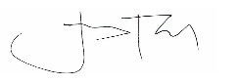

Approved by:

RUEL D. TABADA
General Manager
Dipolog City Water District

FOI ONE PAGE MANUAL (ENGLISH)

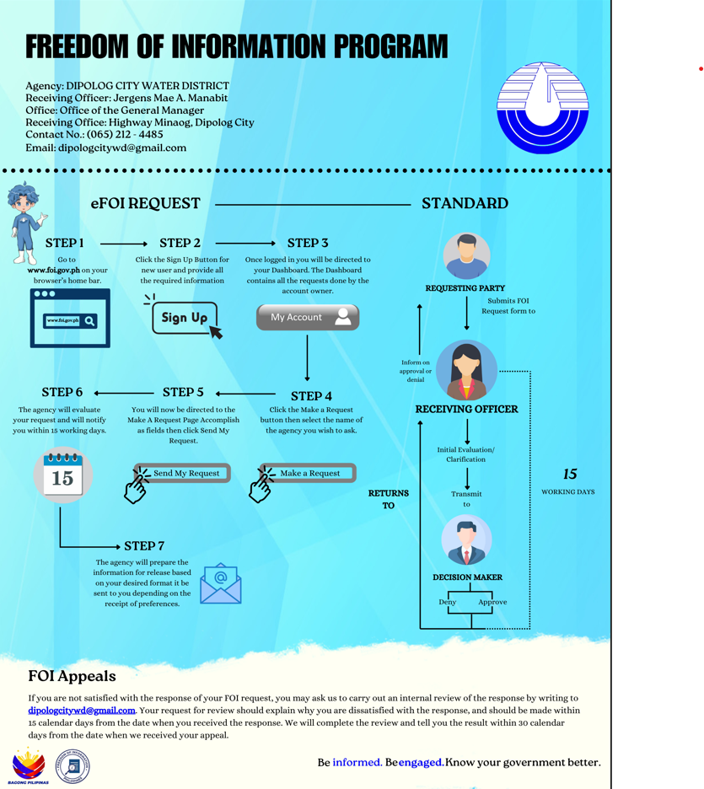

FOI ONE PAGE MANUAL (TAGALOG)
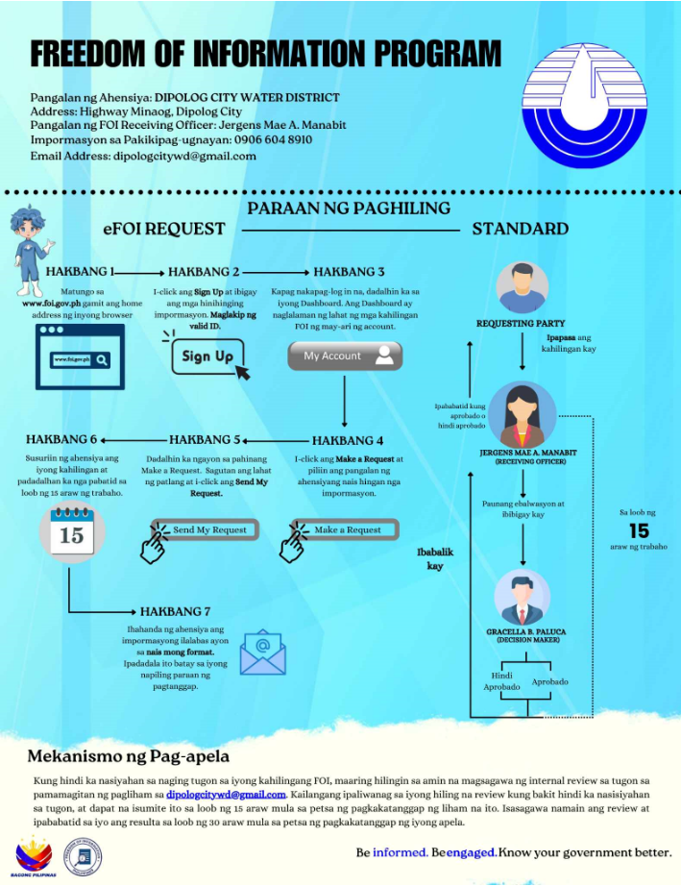

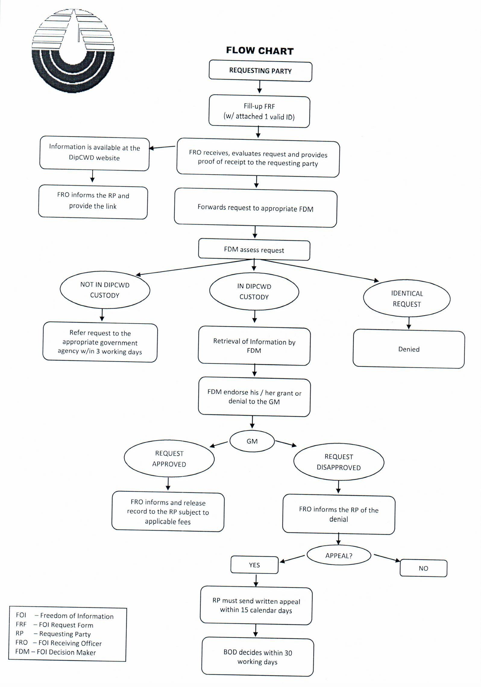

FOI REQUEST FORM
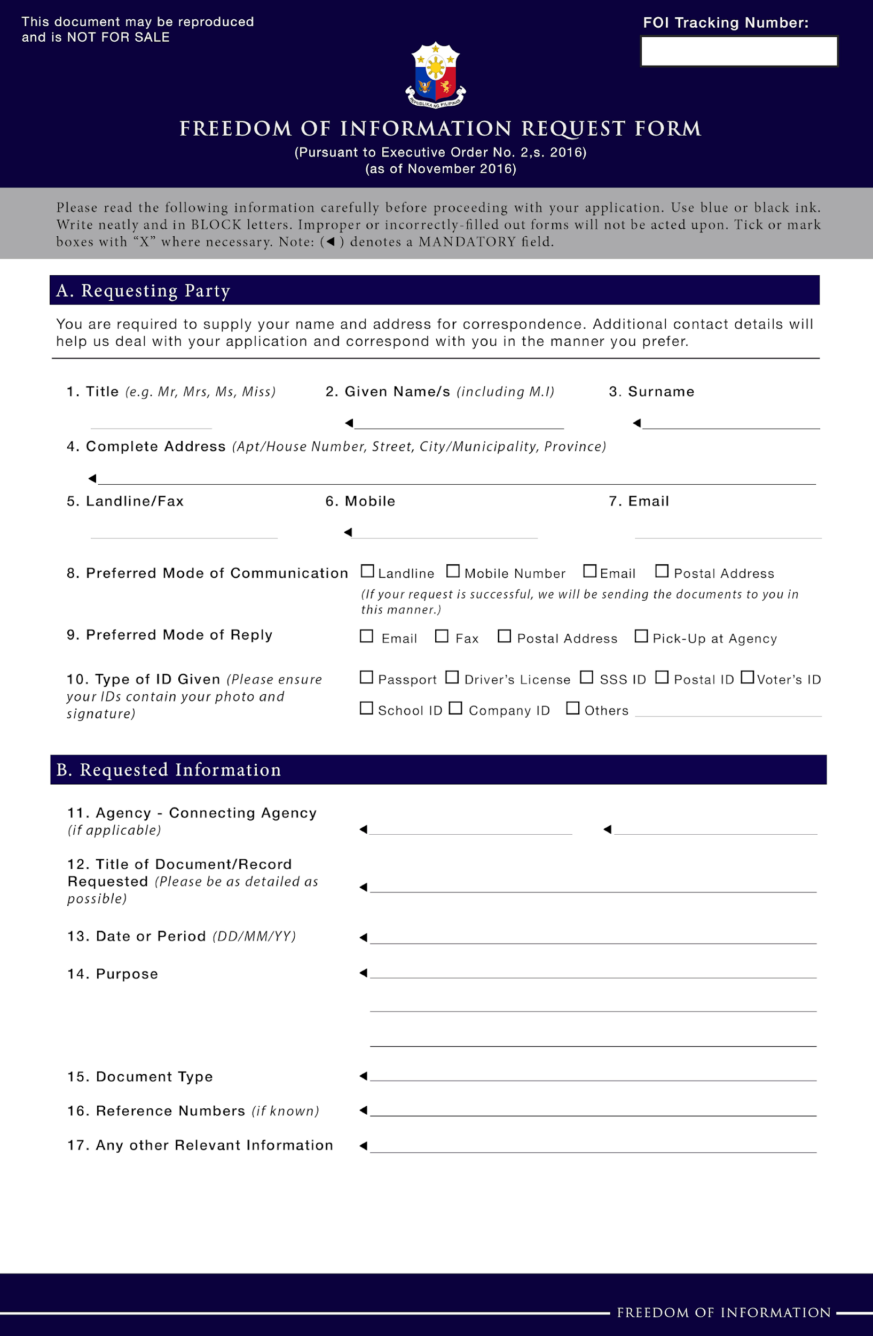

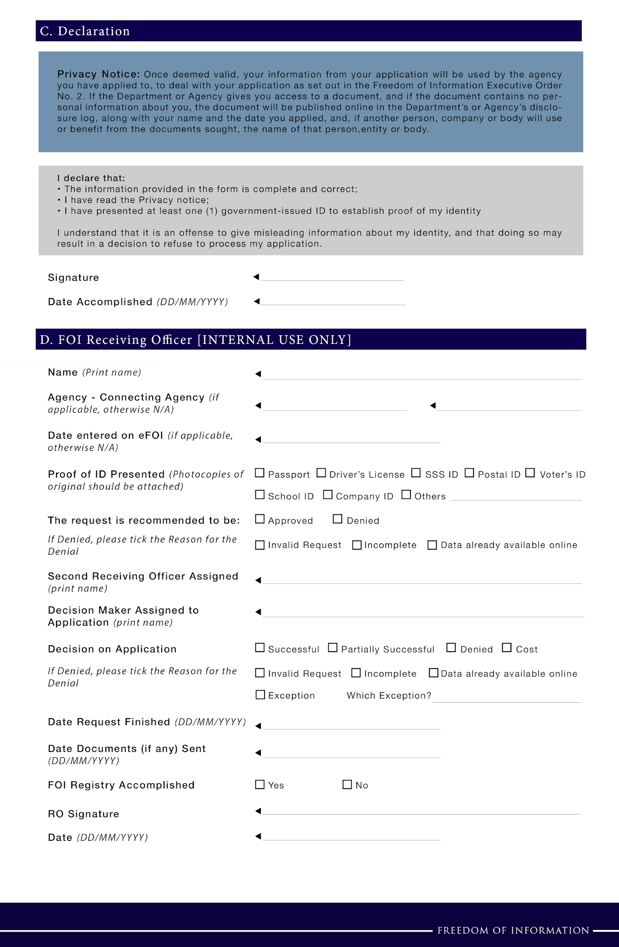

FOI FREQUENTLY ASKED QUESTIONS

        - What is FOI?
Freedom of Information (FOI) is the government’s response to the call for transparency and full public disclosure of information. FOI is a government mechanism which allows Filipino citizens to request any information about the government transactions and operations, provided that it shall not put into jeopardy privacy and matters of national security.

The FOI mechanism for the Executive Branch is enabled via Executive Order No. 2, series of 2016.

  - What is Executive Order No. 2, S. 2016?
Executive Order No. 2 is the enabling order for FOI. EO 2 operationalizes in the Executive Branch the People’s Constitutional right to information. EO 2 also provides the State policies to full public disclosure and transparency in the public service.

EO 2 was signed on 23 July 2016. It is an important enabling mechanism to promote transparency in the government's administrative process. Through FOI, citizens are empowered to make a formal request to get information held by the government, barring certain sensitive and important data related to the nation's security. FOI complements continuing proactive information disclosure efforts where agencies are duty-bound to publish information in the spirit of openness and transparency.

  - Who oversees the implementation of EO 2?
The Presidential Communications Office (PCO) oversees the operation of the FOI program. PCO serves as the coordinator of all government agencies to ensure that the FOI program is properly implemented.

  - Who can make an FOI request?
Any Filipino citizen can make an FOI Request. As a matter of policy, requestors are required to present proof of identification.

  - What can I ask for under EO on FOI?
Information, official records, public records, and documents and papers pertaining to official acts, transactions or decisions, as well as to government research data used as basis for policy development.

  - What agencies can we ask for information?
An FOI request under EO 2 can be made before all government offices under the Executive Branch, including National Government Agencies (NGAs), Government Owned or Controlled Corporations (GOCCs), State Universities and Colleges (SUCs), and Local Water Districts (LWDs)

FOI requests must be sent to the specific agency of interest, to be received by its respective Receiving Officer.

  - How do I make an FOI request?
- The requestor is to fill up a request form and submit it to the agency’s Receiving Officer. The Receiving Officer shall validate the request and logs it accordingly on the FOI tracker.

- If deemed necessary, the Receiving Officer may clarify the request on the same day it was filed, such as specifying the information requested, and providing other assistance needed by the Requestor.
- The request is forwarded to the Decision Maker for proper assessment. The Decision Maker shall check if the agency holds the information requested, if it is already accessible, or if the request is a repeat of any previous request.
- The request shall be forwarded to the officials involved to locate the requested information.
- Once all relevant information is retrieved, officials will check if any exemptions apply, and will recommend appropriate response to the request.
- If necessary, the head of the agency shall provide clearance to the response.
- The agency shall prepare the information for release, based on the desired format of the Requestor. It shall be sent to the Requestor depending on the receipt preference.

  - How much does it cost to make an FOI request?
There are no fees to make a request. But the agency may charge a reasonable fee for necessary costs, including costs of printing, reproduction and/or photocopying.

  - What will I receive in response to an FOI request?
You will be receiving a response either granting or denying your request.

If the request is granted, the information requested will be attached, using a format that you specified. Otherwise, the agency will explain why the request was denied.

  - How long will it take before I get a response?
It is mandated that all replies shall be sent fifteen (15) working days after the receipt of the request. The agency will be sending a response, informing of an extension of processing period no longer than twenty (20) working days, should the need arise.

  - What if I never get a response?
If the agency fails to provide a response within the required fifteen (15) working days, the Requestor may write an appeal letter to the Central Appeals and Review Committee within fifteen (15) calendar days from the lapse of required response period. The appeal shall be decided within thirty (30) working days by the Central Appeals and Review Committee.

If all administrative remedies are exhausted and no resolution is provided, requestors may file the appropriate case in the proper courts in accordance with the Rules of Court.

  - What will happen if my request is not granted?
If you are not satisfied with the response, the Requestor may write an appeal letter to the Central Appeals and Review Committee within fifteen (15) calendar days from the lapse of the required response period. The appeal shall be decided within thirty (30) working days by the Central Appeals and Review Committee.

If all administrative remedies are exhausted and no resolution is provided, requestors may file the appropriate case in the proper courts in accordance with the Rules of Court.

LIST OF EXCEPTIONS

The following are the exceptions to the right of access to information, as recognized by the Constitution, existing laws, or jurisprudence:

- Information covered by Executive privilege;

- Privileged information relating to national security, defense or international relations;

- Information concerning law enforcement and protection of public and personal safety;

- Information deemed confidential for the protection of the privacy of persons and certain individuals such as minors, victims of crimes, or the accused;

- Information, documents or records known by reason of official capacity and are deemed as confidential, including those submitted or disclosed by entities to government agencies, tribunals, boards, or officers, in relation to the performance of their functions, or to inquiries or investigation conducted by them in the exercise of their administrative, regulatory or quasi-judicial powers;

- Prejudicial premature disclosure;

- Records of proceedings or information from proceedings which, pursuant to law or relevant rules and regulations, are treated as confidential or privileged;

- Matters considered confidential under banking and finance laws, and their amendatory laws; and

- Other exceptions to the right to information under laws, jurisprudence, rules and regulations.

For the implementation of the exceptions to the right of access to information, the following provide the salient details and legal bases that define the extent and application of the exceptions.

- Information covered by Executive privilege:
  - Presidential conversations, correspondences, and discussions in closed-door Cabinet meetings; and
  - Matters covered by deliberative process privilege, namely:
    - advisory opinions, recommendations and deliberations comprising part of a process by which governmental decisions and policies are formulated; intra-agency or inter-agency recommendations or communications during the stage when common assertions are still in the process of being formulated or are in the exploratory stage; or information pertaining to the decision-making of executive officials; and
    - information, record or document comprising drafts of decisions, orders, rulings, policy decisions, memoranda, etc.;

- Privileged information relating to national security, defense or international relations:
  - Information, record, or document that must be kept secret in the interest of national defense or security;
  - Diplomatic negotiations and other information required to be kept secret in the conduct of foreign affairs; and
  - Patent applications, the publication of which would prejudice national security and interests;

- Information concerning law enforcement and protection of public and personal safety:
- Investigation records compiled for law enforcement purposes or information which if written would be contained in such records, but only to the extent that the production of such records or information would –

  - interfere with enforcement proceedings;
  - deprive a person of a right to a fair trial or an impartial adjudication;

  - disclose the identity of a confidential source and in the case of a record compiled by a criminal law enforcement authority in the course of a criminal investigation, or by an agency conducting a lawful national security intelligence investigation, confidential information furnished only by the confidential source; or
  - unjustifiably disclose investigative techniques and procedures;

- Informer’s privilege or the privilege of the Government not to disclose the identity of a person or persons who furnish information of violations of law to officers charged with the enforcement of law;
- When disclosure of information would put the life and safety of an individual in imminent danger;
- Any information given by informants leading to the recovery of car napped vehicles and apprehension of the persons charged with car napping; and
- All proceedings involving application for admission into the Witness Protection Program and the action taken thereon;

- Information deemed confidential for the protection of the privacy of persons and certain individuals such as minors, victims of crimes, or the accused. These include:
(1) about an individual’s race, ethnic origin, marital status, age, color, and religious, philosophical or political affiliations;
(2) about an individual’s health, education, genetic or sexual life of a person, or to any proceeding for any offense committed or alleged to have been committed by such person, the disposal of such proceedings, or the sentence of any court in such proceedings;
(3) issued by government agencies peculiar to an individual which includes, but not limited to, social security numbers, previous or current health records, licenses or its denials, suspension or revocation, and tax returns; and

(4) specifically established by an executive order or an act of Congress to be kept classified.

However, personal information may be disclosed to the extent that the requested information is shown to be a matter of public concern or interest, shall not meddle with or disturb the private life or family relations of the individual and is not prohibited by any law or regulation. Any disclosure of personal information shall be in accordance with the principles of transparency, legitimate purpose and proportionality.

Disclosure of personal information about any individual who is or was an officer or employee of a government institution shall be allowed, provided that such information relates to the position or functions of the individual, including: (1) the fact that the individual is or was an officer or employee of the government institution; (2) the title, business address and office telephone number of the individual; (3) the classification, salary range and responsibilities of the position held by the individual;

and (4) the name of the individual on a document prepared by the individual in the course of employment with the government;

- Source of any news report or information appearing in newspapers, magazines or periodicals of general circulation obtained in confidence; and

- Records of proceedings and processes deemed confidential by law for the privacy and/or protection of certain individuals, such as children, victims of crime, witnesses to a crime or rehabilitated drug offenders, including those pertaining to the following:

(1) records of child and family cases;
children in conflict with the law from initial contact until final disposition of the case;
(3) a child who is a victim of any offense under the Anti-Child Pornography Act of 2009, including the name and personal circumstances of the child, or the child’s immediate family, or any other information tending to establish the child’s identity;
(4) a child witness, who is a victim of a crime, an accused of a crime, or a witness to a crime, including the name, address, telephone number, school, or other identifying information of a child or an immediate family of the child;
(5) cases involving violence against women and their children, including the name, address, telephone number, school, business, address, employer, or other identifying information of a victim or an immediate family member;
(6) trafficked persons, including their names and personal circumstances, or any other information tending to establish the identity of the trafficked person;
(7) names of victims of child abuse, exploitation or discrimination;
(8) disclosure which would result in undue and sensationalized publicity of any case involving a child in conflict with the law, child abuse, or violation of anti-trafficking of persons;
(9) records, documents and communications of proceedings involving domestic and inter-country adoptions, including the identity of the child, natural parents and adoptive parents;
(10) names of students who committed acts of bullying or retaliation;

(11) first time minor (drug) offenders under suspended sentence who comply with applicable rules and regulations of the Dangerous Drugs Board and who are subsequently discharged; judicial and medical records of drug dependents under the voluntary submission program; and records of a drug dependent who was rehabilitated and discharged from treatment and rehabilitation centers under the compulsory submission program, or who was charged for violation of Section 15 (use of dangerous drugs) of the Comprehensive Dangerous Drugs Act of 2002, as amended; and
(12) identity, status and medical records of individuals with Human Immunodeficiency Virus (HIV), as well as results of HIV/Acquired Immune Deficiency Syndrome (AIDS) testing;
- Information, documents or records known by reason of official capacity and are deemed as confidential, including those submitted or disclosed by entities to government agencies, tribunals, boards, or officers, in relation to the performance of their functions, or to inquiries or investigation conducted by them in the exercise of their administrative, regulatory or quasi-judicial powers, such as but not limited to the following:

    - Trade secrets, intellectual property, business, commercial, financial and other proprietary information;
    - Data furnished to statistical inquiries, surveys and censuses of the Philippine Statistics Authority (PSA);
    - Records and reports submitted to the Social Security System by the employer or member;
    - Information gathered from HIV/AIDS contact tracing and all other related health intelligence activities;
    - Confidential information submitted to the Philippine Competition Commission prohibited from disclosure by law, including the identity of the person who provided the information under condition of anonymity;
    - Applications and supporting documents filed pursuant to the Omnibus Investments Code of 1987;
    - Documents submitted through the Government Electronic Procurement System;
    - Information obtained from accessing any electronic key, electronic data message, or electronic document, book, register, correspondence, information or other material pursuant to any powers conferred under the Electronic Commerce Act of 2000;

    - Any confidential information supplied by the contractors in mineral agreements, and financial or technical assistance agreements pursuant to the Philippine Mining Act of 1995 and its Implementing Rules and Regulations (IRR), during the term of the project to which it relates;
    - Information received by the Department of Tourism (DOT) in relation to the accreditation of accommodation establishments (such as hotels and resorts) and travel and tour agencies;
    - The fact that a covered transaction report to the Anti-Money Laundering Council (AMLC) has been made, the contents thereof, or any information in relation thereto;
    - Information submitted to the Tariff Commission which is by nature confidential or submitted on a confidential basis;
    - Certain information and reports submitted to the Insurance Commissioner pursuant to the Insurance Code;
    - Information on registered cultural properties owned by private individuals;
    - Data submitted by a higher education institution to the Commission on Higher Education (CHED); and
    - Any secret, valuable or proprietary information of a confidential character known to a public officer, or secrets of private individuals;

- Information of which a premature disclosure would:

- in the case of a department, office or agency which agency regulates currencies, securities, commodities, or financial institutions, be likely to lead to significant financial speculation in currencies, securities, or commodities, or significantly endanger the stability of any financial institution; or
- be likely or significantly frustrate implementation of a proposed official action, except such department, office or agency has already disclosed to the public the content or nature of its proposed action, or where the department, office or agency is required by law to make such disclosure on its own initiative prior to taking final official action on such proposal.

- Records of proceedings or information from proceedings which, pursuant to law or relevant rules and regulations, are treated as confidential or privileged, including but not limited to the following:

    - Mediation and domestic or international arbitration proceedings, including records, evidence and the arbitral awards, pursuant to the Alternative Dispute Resolution Act of 2004;
    - Matters involved in an Investor-State mediation;
    - Information and statements made at conciliation proceedings under the Labor Code;
    - Arbitration proceedings before the Construction Industry Arbitration Commission (CIAC);
    - Results of examinations made by the Securities and Exchange Commission (SEC) on the operations, books and records of any corporation, and all interrogatories propounded by it and the answers thereto;
    - Information related to investigations which are deemed confidential under the Securities Regulations Code;
    - All proceedings prior to the issuance of a cease and desist order against pre-need companies by the Insurance Commission;
    - Information related to the assignment of the cases to the reviewing prosecutors or the undersecretaries in cases involving violations of the Comprehensive Dangerous Drugs Act of 2002;
    - Investigation report and the supervision history of a probationer;
    - Those matters classified as confidential under the Human Security Act of 2007;
    - Preliminary investigation proceedings before the committee on decorum and investigation of government agencies; and
    - Those information deemed confidential or privileged pursuant to pertinent rules and regulations issued by the Supreme Court, such as information on disbarment proceedings, DNA profiles and results, or those ordered by courts to be kept confidential;

- Matters considered confidential under banking and finance laws and their amendatory laws, such as:

  - RA No. 1405 (Law on Secrecy of Bank Deposits);
  - RA No. 6426 (Foreign Currency Deposit Act of the Philippines) and relevant regulations;
  - RA No. 8791 (The General Banking Law of 2000);
  - RA No. 9160 (Anti-Money Laundering Act of 2001); and
  - RA No. 9510 (Credit Information System Act);

- Other exceptions to the right to information under laws, jurisprudence, rules and regulations, such as:

  - Those deemed confidential pursuant to treaties, executive agreements, other international agreements, or international proceedings, such as:

    - When the disclosure would prejudice legitimate commercial interest or competitive position of investor-states pursuant to investment agreements;
    - Those deemed confidential or protected information pursuant to United Nations Commission on International Trade Law Rules on Transparency in Treaty-based Investor-State Arbitration and Arbitration Rules (UNCITRAL Transparency Rules); and
    - Refugee proceedings and documents under the 1951 Convention Relating to the Status of Refugees, as implemented by DOJ Circular No. 58 (s. 2012);

  - Testimony from a government official, unless pursuant to a court or legal order;

  - When the purpose for the request of Statement of Assets, Liabilities and Net Worth is any of the following:
(1) any purpose contrary to morals or public policy; or
(2) any commercial purpose other than by news and communications media for dissemination to the general public;

  - Lists, abstracts, summaries of information requested when such lists, abstracts or summaries are not part of the duties of the government office requested;

  - Those information and proceedings deemed confidential under rules and regulations issued by relevant government agencies or as decided by the courts;

  - Requested information pertains to comments and disclosures on pending cases in judicial proceedings; and

  - Attorney-client privilege existing between government lawyers and their client.

FOI RESPONSE TEMPLATE - DOCUMENT ENCLOSED

DATE

Dear __________,

Greetings!

Thank you for your request dated <insert data> under Executive Order No. 2 (s. 2016) on Freedom of Information in the Executive Branch.

Your request

You asked for <quote request exactly, unless it is too long/complicated>.

Response to your request

Your FOI request is approved. I enclose a copy of [some/most/all]* of the information you requested [in the format you asked for]

Thank you.

Respectfully,

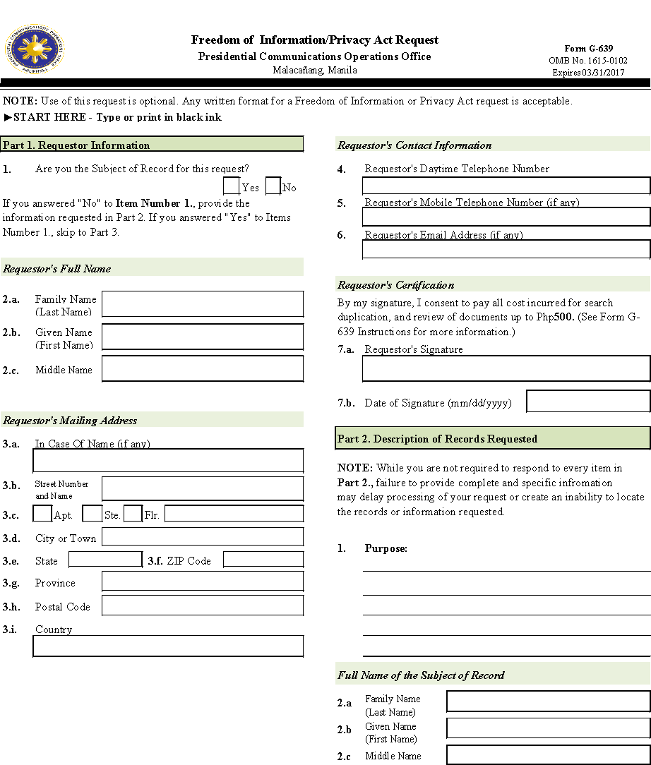
_______________________
FOI Receiving Officer

FOI RESPONSE TEMPLATE - ANSWER

DATE

Dear __________,

Greetings!

Thank you for your request dated <insert data> under Executive Order No. 2 (s. 2016) on Freedom of Information in the Executive Branch.

Your request

You asked for <quote request exactly, unless it is too long/complicated>.

Response to your request

Your FOI request is approved. The answer to your request is <insert answer>

Thank you.

Respectfully,

_______________________
FOI Receiving Officer

FOI RESPONSE TEMPLATE - DOCUMENT AVAILABLE ONLINE

DATE

Dear __________,

Greetings!

Thank you for your request dated <insert data> under Executive Order No. 2 (s. 2016) on Freedom of Information in the Executive Branch.

Your request

You asked for <quote request exactly, unless it is too long/complicated>.

Response to your request

[Some/Most/All] of the information you have requested is already available online from <add details of where that specific information can be obtained e.g. data.gov.ph, foi.gov.ph or other government websites>.

Your right to request a review

If you are unhappy with this response to your FOI request, you may make an appeal by writing to <insert name of Official> at <insert email and address>. Your appeal should explain why you are dissatisfied with this response, and should be made within 15 calendar days from the date when you received this letter. We will complete the review and tell you the result within 30 workings days from the date when we receive your appeal.

Thank you.

Respectfully,

_______________________
FOI Receiving Officer

FOI RESPONSE TEMPLATE - DOCUMENT NOT AVAILABLE

DATE

Dear __________,

Greetings!

Thank you for your request dated <insert data> under Executive Order No. 2 (s. 2016) on Freedom of Information in the Executive Branch.

Your request

You asked for <quote request exactly, unless it is too long/complicated>.

Response to your request

While our aim is to provide information whenever possible, in this instance this Office does not have [some of]* the information you have requested. However, you may wish to contact <insert name of other authority/organization> at<insert contact details. Who may be able to help you. The reasons why we do not have the information are explained in the Annex to this letter.

Your right to request a review

If you are unhappy with this response to your FOI request, you may make an appeal by writing to <insert name of Official> at <insert email and address>. Your appeal should explain why you are dissatisfied with this response, and should be made within 15 calendar days from the date when you received this letter. We will complete the review and tell you the result within 30 working days from the date when we receive your appeal.

Thank you.

Respectfully,

_______________________
FOI Receiving Officer

FOI RESPONSE TEMPLATE – UNDER EXCEPTIONS

DATE

Dear __________,

Greetings!

Thank you for your request dated <insert data> under Executive Order No. 2 (s. 2016) on Freedom of Information in the Executive Branch.

Your request
You asked for <quote request exactly, unless it is too long/complicated>.

Response to your request

While our aim is to provide information whenever possible, in this instance we are unable to provide [some of]* the information you have requested because an exception(s) under section(s) <insert specific section number(s) of the List of Exceptions applies to that information>. The reasons why that exemption(s) applies are explained in the Annex to this letter.

Your right to request a review

If you are unhappy with this response to your FOI request, you may make an appeal by writing to <insert name of Official> at <insert email and address>. Your appeal should explain why you are dissatisfied with this response, and should be made within 15 calendar days from the date when you received this letter. We will complete the review and tell you the result within 30 workings days from the date when we receive your appeal.

Thank you.

Respectfully,

_______________________
FOI Receiving Officer

FOI RESPONSE TEMPLATE – IDENTICAL REQUEST

DATE

Dear __________,

Greetings!

Thank you for your request dated <insert data> under Executive Order No. 2 (s. 2016) on Freedom of Information in the Executive Branch.

Your request
You asked for <quote request exactly, unless it is too long/complicated>.

Response to your request

While our aim is to provide information whenever possible, in this instance we are unable to provide the information you have requested because it is substantially similar or identical to a previous request that you made on <insert date of previous request>, which we responded to on <insert date of response>.

Your right to request a review

If you are unhappy with this response to your FOI request, you may make an appeal by writing to <insert name of Official> at <insert email and address>. Your appeal should explain why you are dissatisfied with this response, and should be made within 15 calendar days from the date when you received this letter. We will complete the review and tell you the result within 30 workings days from the date when we receive your appeal.

Thank you.

Respectfully,

_______________________
FOI Receiving Officer

EXECUTIVE ORDER NO. 2, SERIES OF 2016

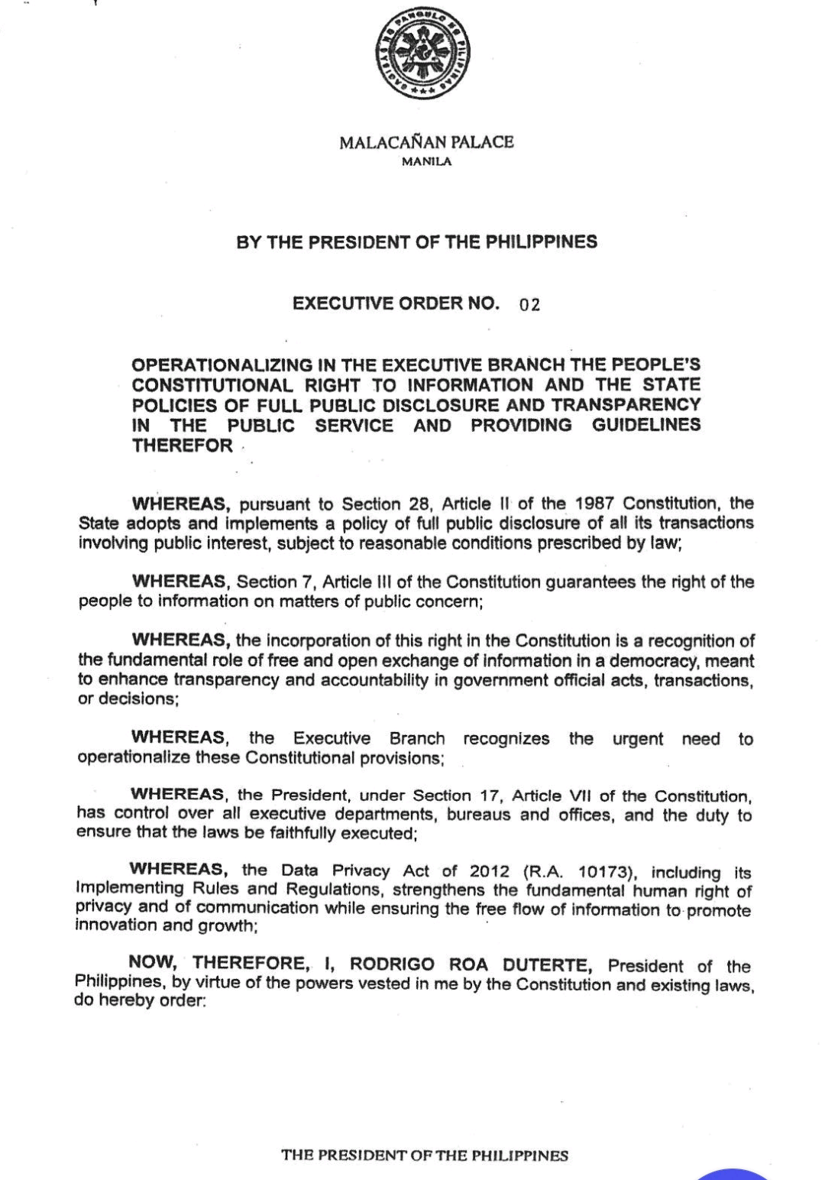

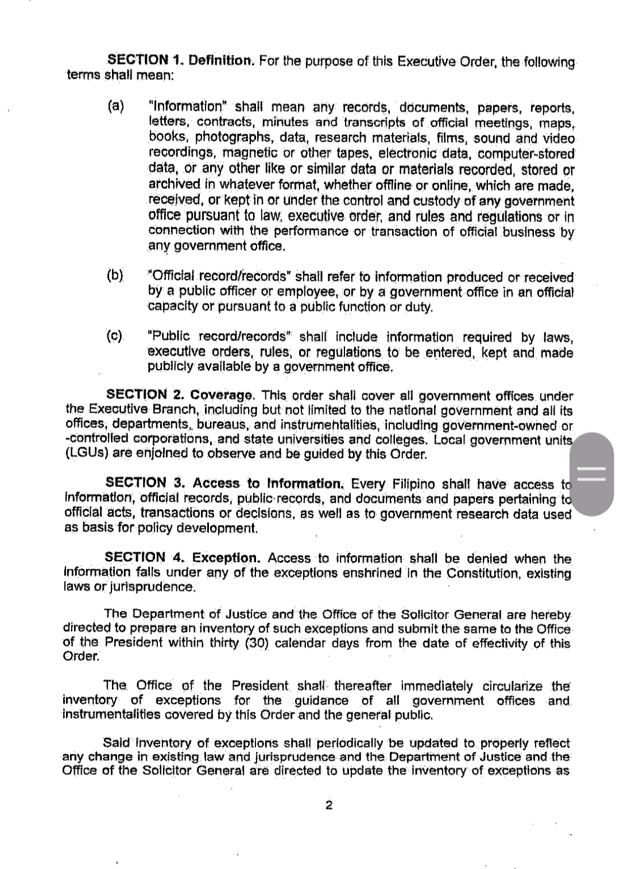

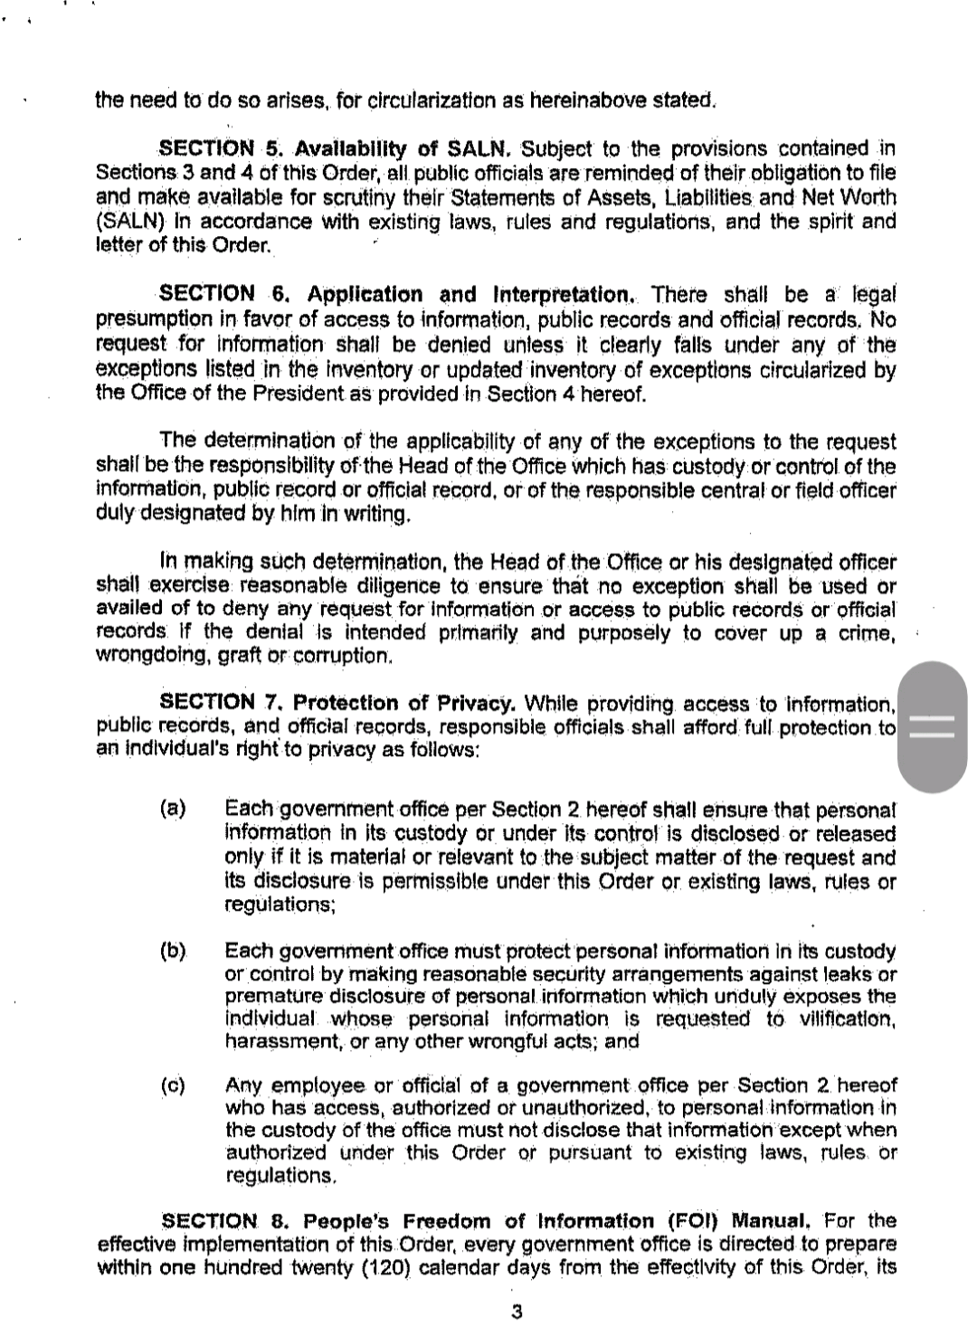

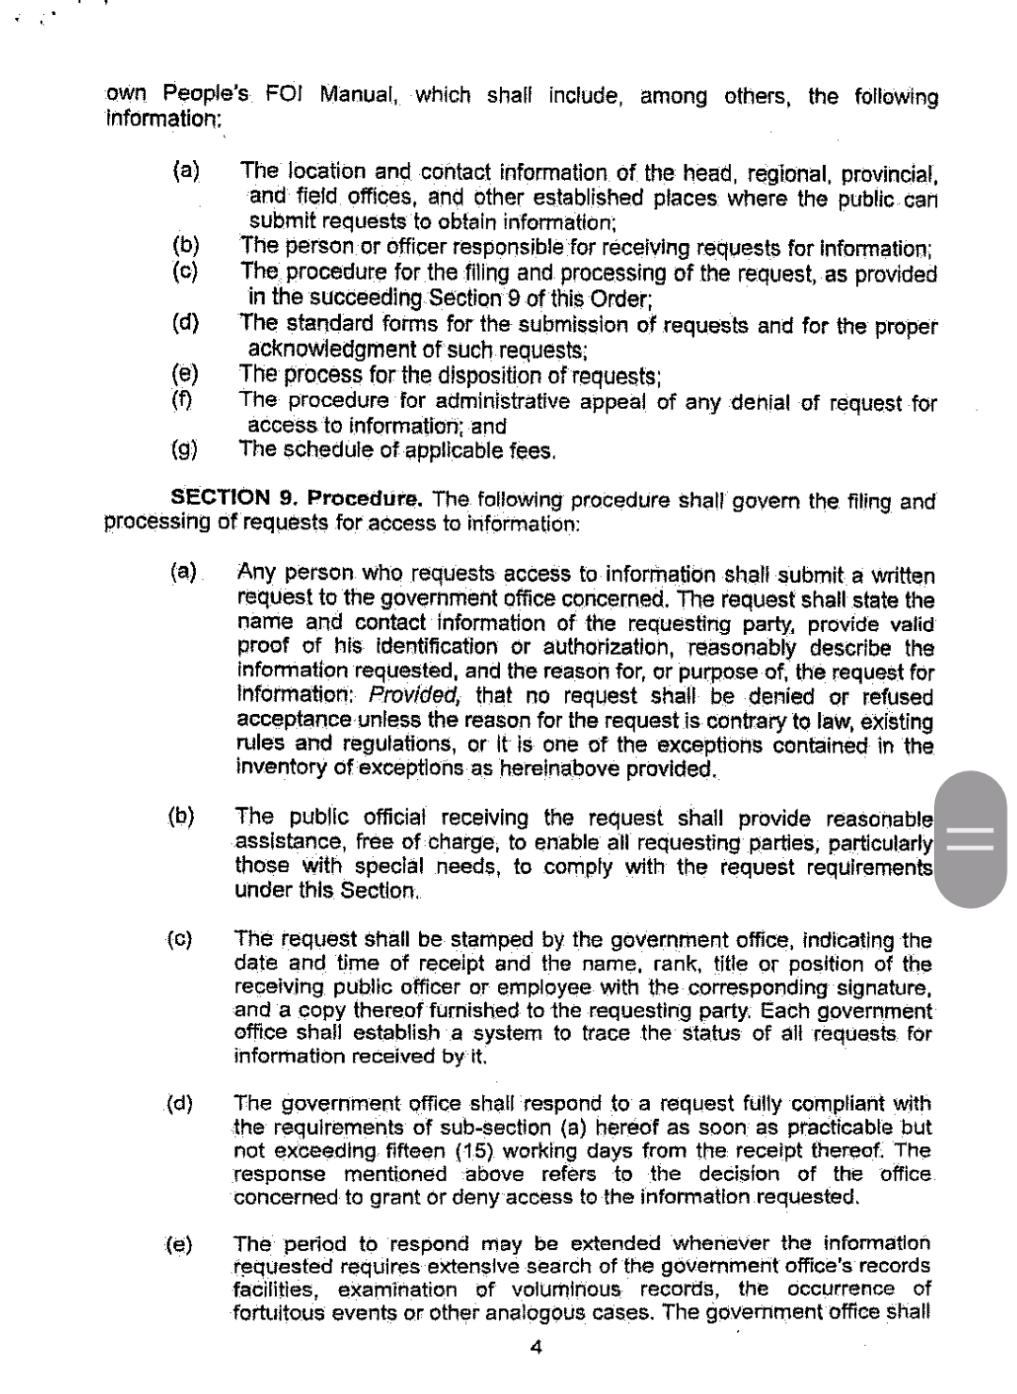

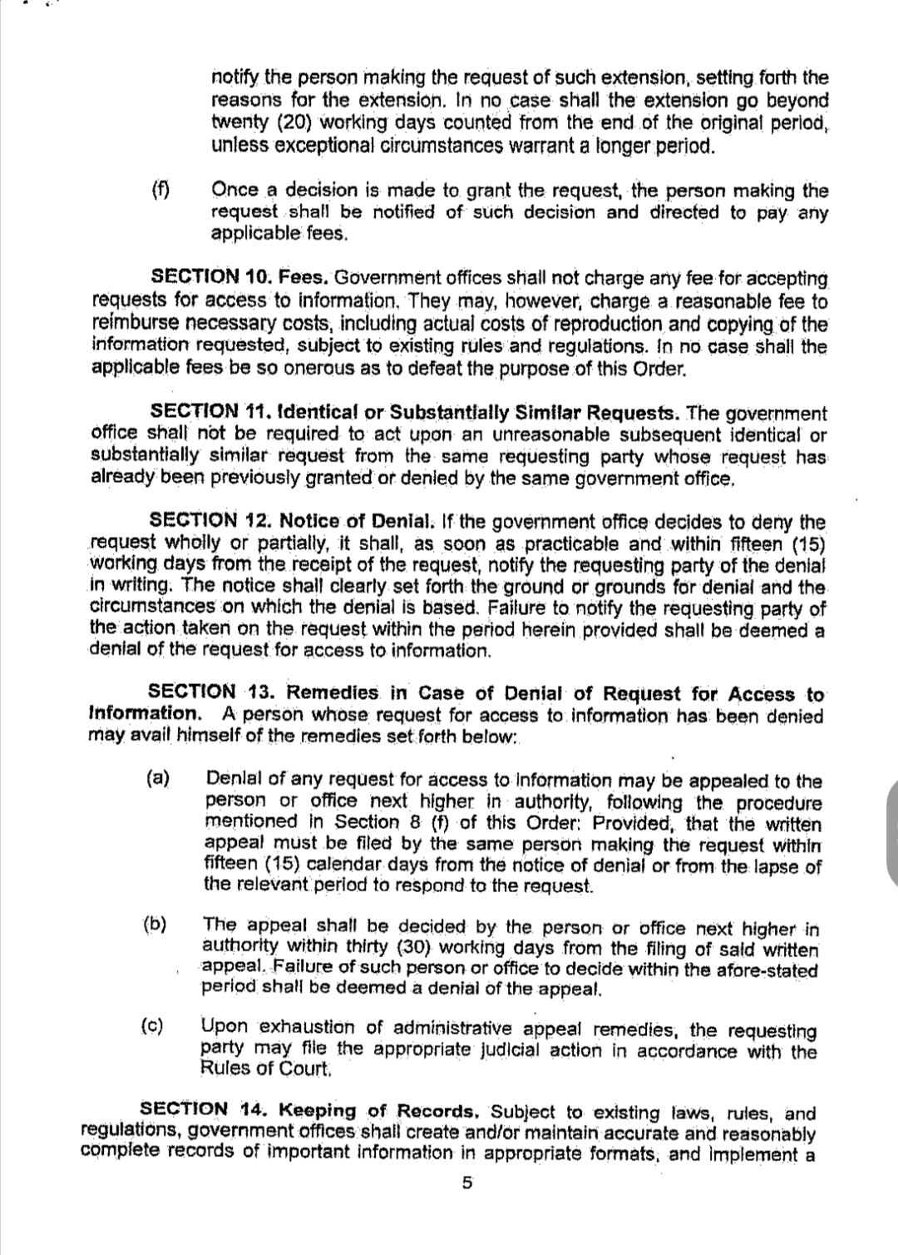

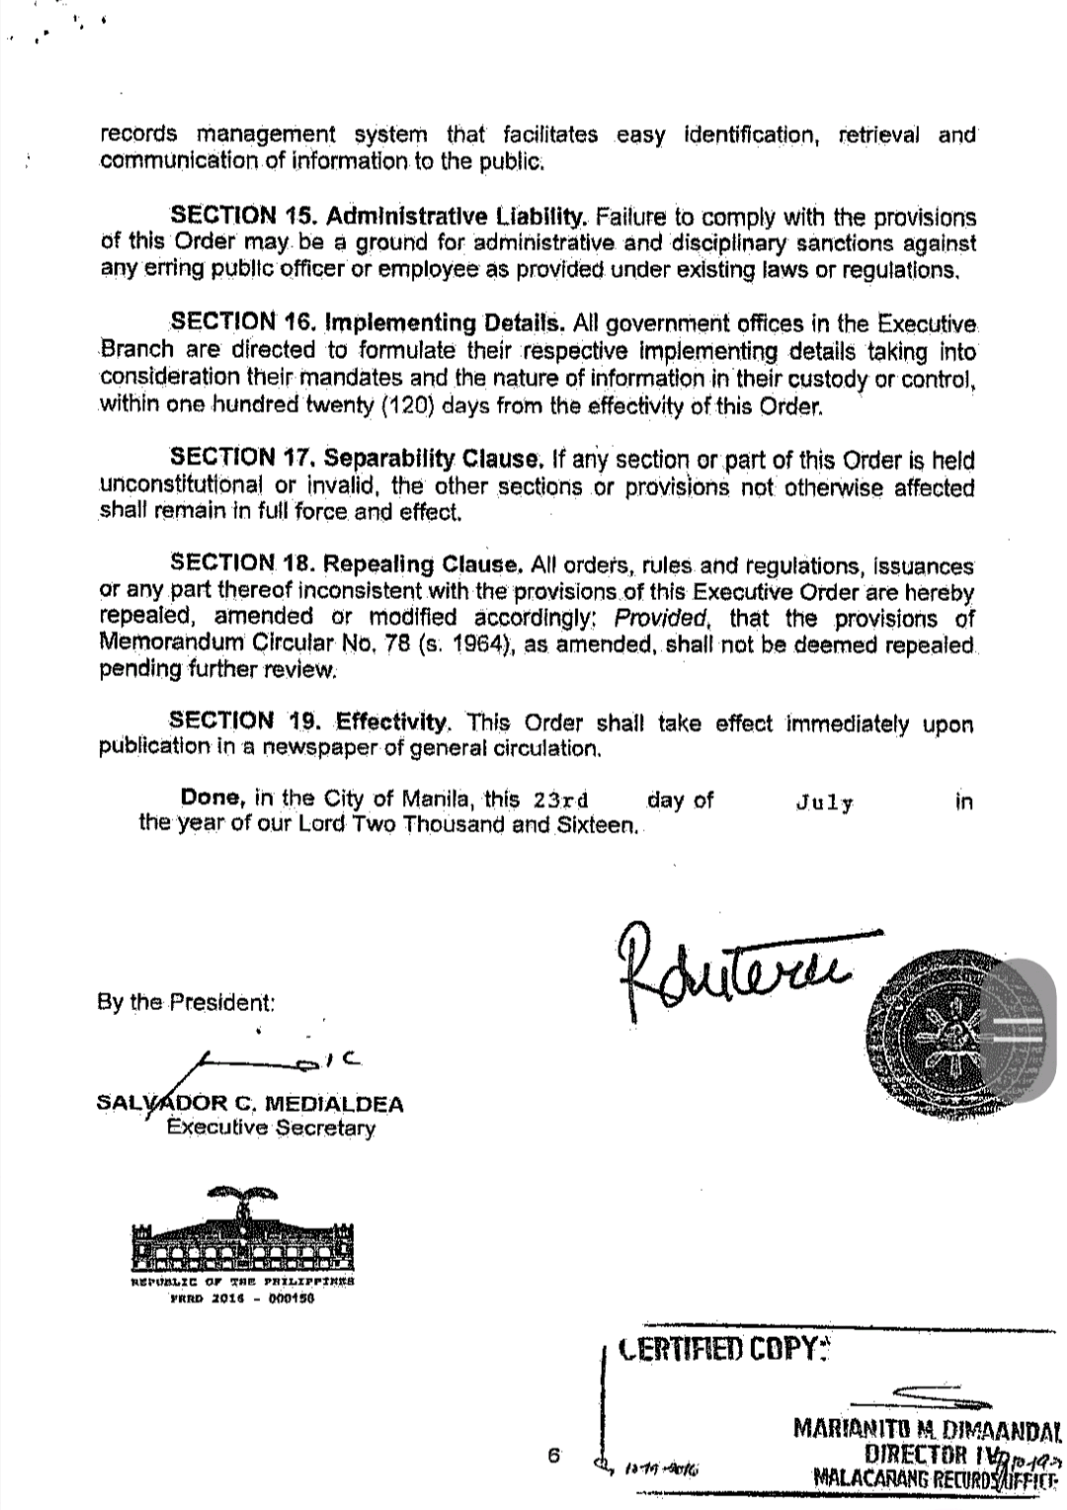

FOI MEMORANDUM CIRCULAR NO. 1 S 2020
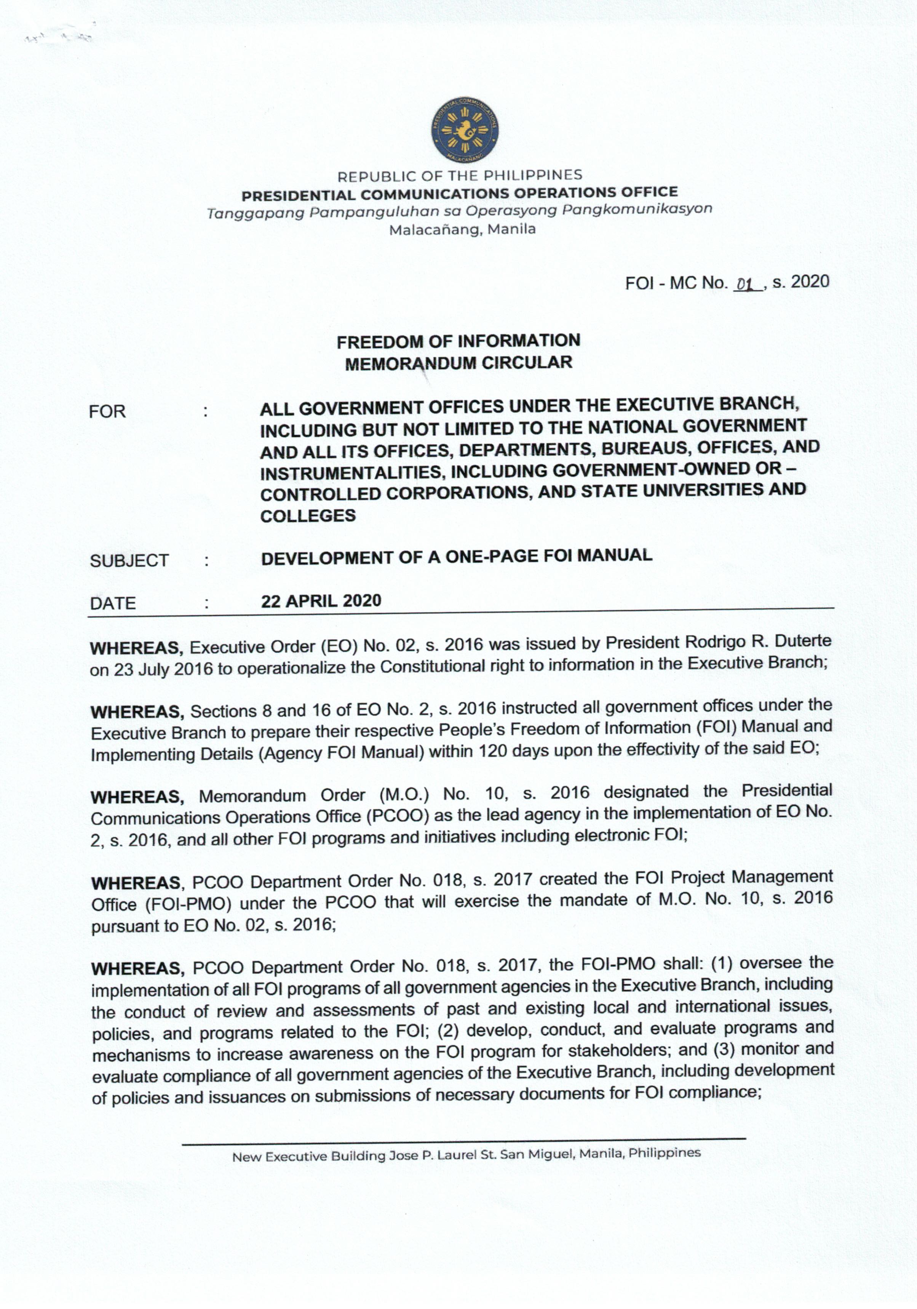

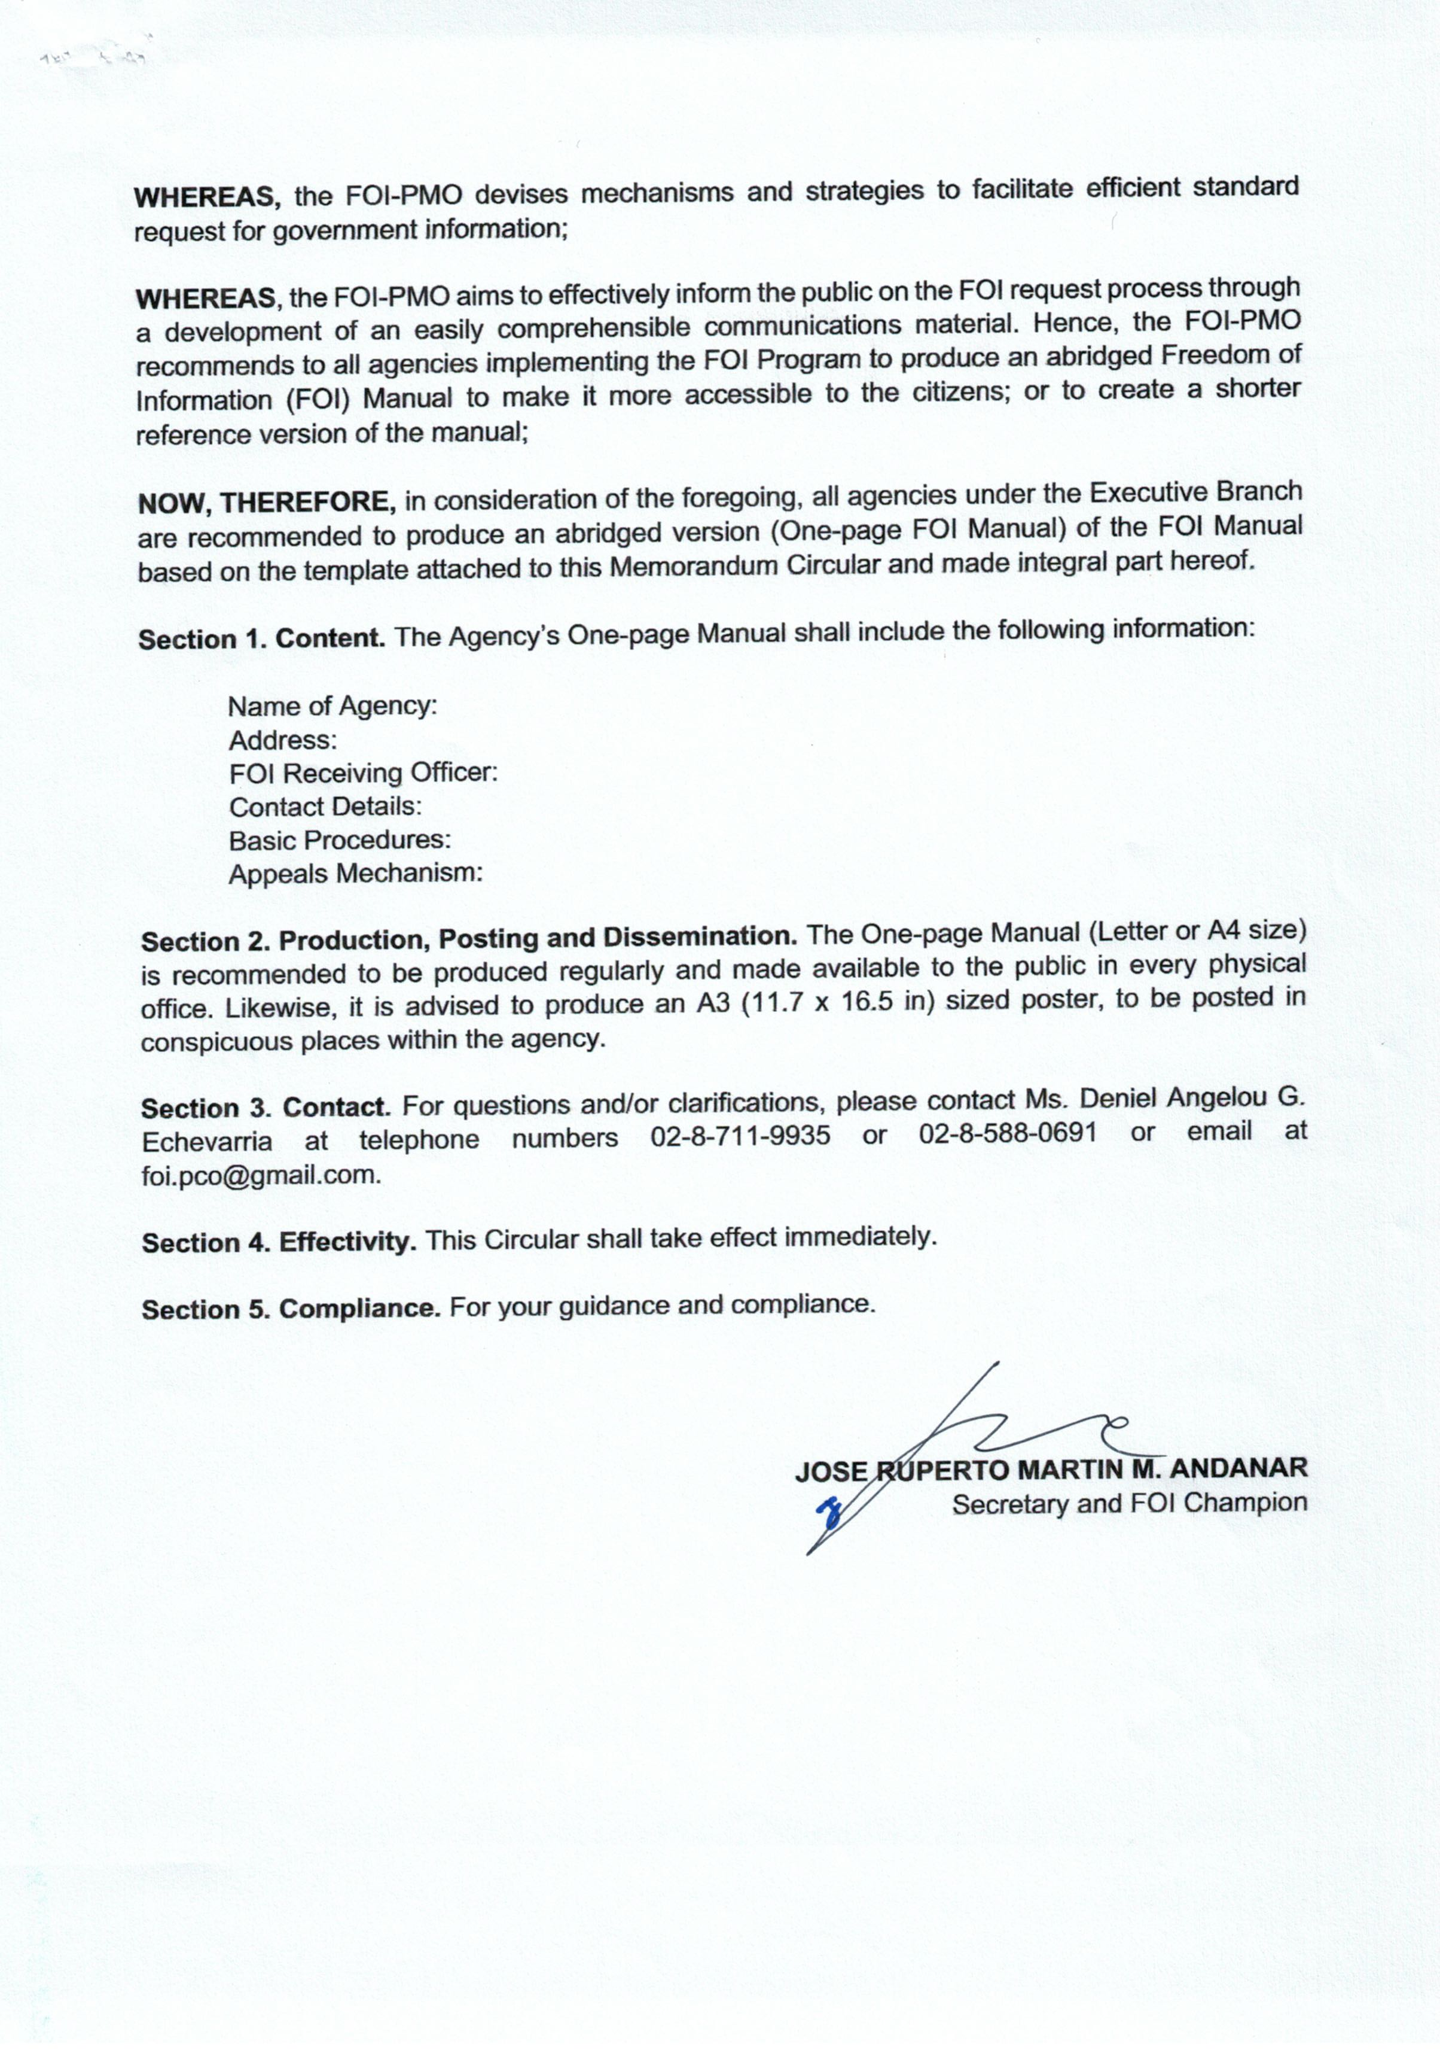

SAMPLE FOI ONE PAGE MANUAL
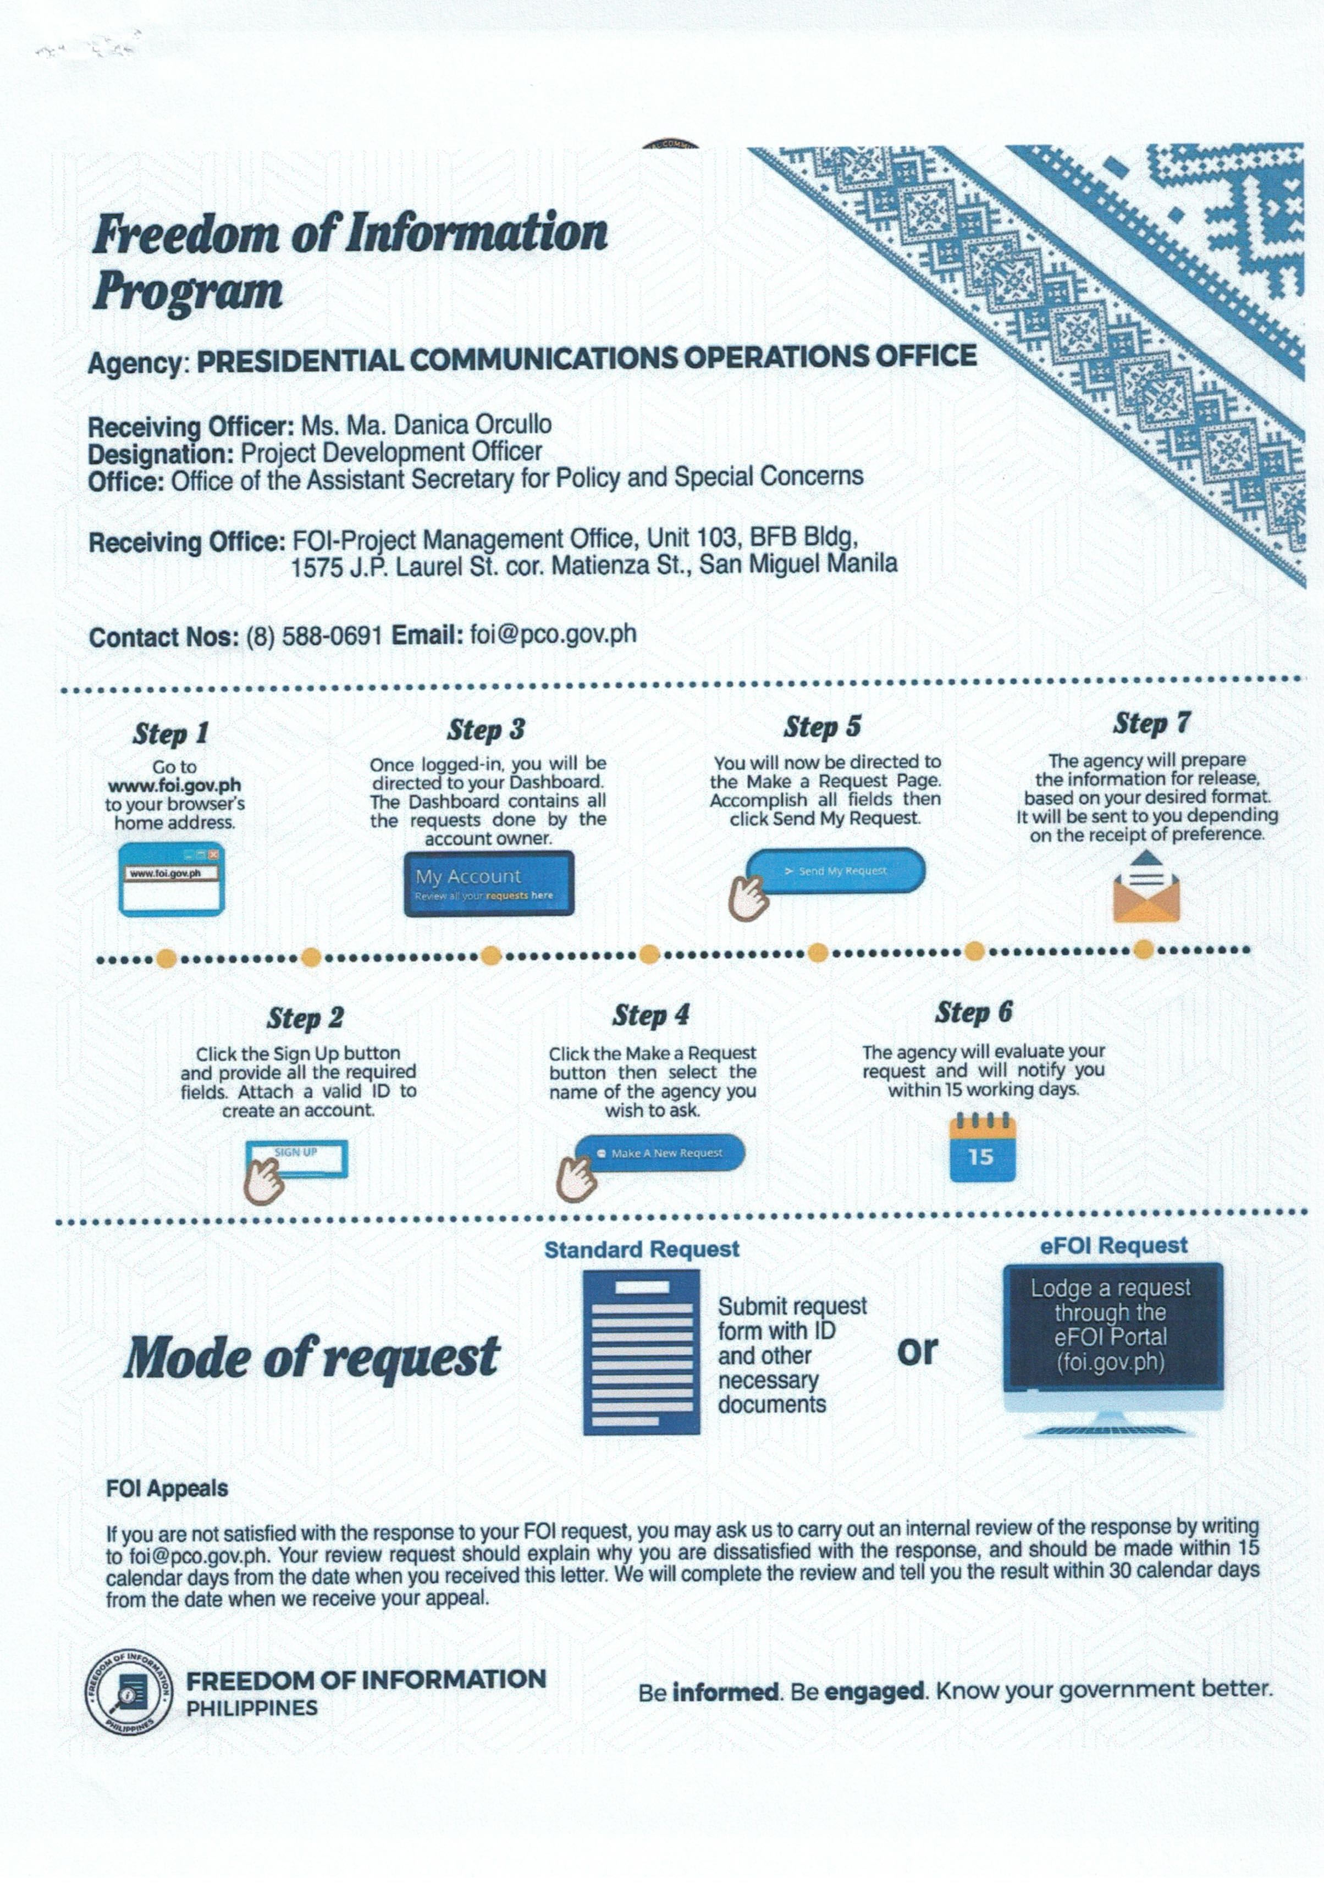

These exceptions only apply to governmental bodies within the control and supervision of the Executive department. Unless specifically identified, these exceptions may be invoked by all officials, officers, or employees in the Executive branch in possession of the relevant records or information.
As enumerated in the Memorandum from the Office of the Executive Secretary entitled, “Inventory of Exceptions to Executive Order No. 2 (s. 2016)”, dated 24 November 2016, signed by Executive Secretary Salvador C. Medialdea.
³ This exception may only be invoked by the President and his close advisors. The extent of the privilege is defined by applicable jurisprudence: Senate v. Ermita, G.R. No. 169777, 20 April 2006, 488 SCRA 1; Neri v. Senate Committee on Accountability of Public Officers and Investigations, G.R. No. 180643, 4 September 2008, 564 SCRA 152; Akbayan v. Aquino, G.R. No. 170516, 16 July 2008, 558 SCRA 468; and Chavez v. PCGG, G.R. No. 130716, 9 December 1998, 299 SCRA 744.
Akbayan v. Aquino, supra; Chavez v. NHA, G.R. No. 164527, 15 August 2007; and Chavez v. PCGG, supra. The privilege of invoking this exception ends when the executive agency adopts a definite proposition (Department of Foreign Affairs v. BCA International Corp., G.R. No. 210858, 20 July 2016).
Section 3(d) Rule IV, Rules Implementing the Code of Conduct and Ethical Standards for Public Officials and Employees (Rules on CCESPOE). Drafts of decisions, orders, rulings, policy decisions, memoranda, and the like, such as resolutions prepared by the investigating prosecutor prior to approval for promulgation and release to parties [Revised Manual for Prosecutors of the Department of Justice (DOJ)] are also covered under this category of exceptions.
Almonte v. Vasquez, G.R. No. 95367, 23 May 1995, 244 SCRA 286; Chavez v. PCGG, supra; Legaspi v. Civil Service Commission, L-72119, 29 May 1987, 150 SCRA 530; Chavez v. NHA, supra; Neri v. Senate, supra; Chavez v. Public Estates Authority, G.R. No. 133250, 9 July 2002, 384 SCRA 152; and Section 3(a), Rule IV, Rules on CCESPOE. This exception generally includes matters classified under Memorandum Circular (MC) No. 78, as amended by MC No. 196 as “Top Secret,” “Secret,” “Confidential,” and “Restricted.”
Akbayan v. Aquino, supra; Section 3(a) Rule IV, Rules on CCESPOE. This privilege may be invoked by the Department of Foreign Affairs and other government bodies involved in diplomatic negotiations.
The applicability of this exception is determined by the Director General of the Intellectual Property Office and subject to the approval of the Secretary of the Department of Trade and Industry. Section 44.3 of the Intellectual Property Code (RA No. 8293, as amended by RA No. 10372).
Section 3(f), Rule IV, Rules on CCESPOE; Chavez v. PCGG, supra. May be invoked by law enforcement agencies.
Akbayan v. Aquino, supra; and Section 51, Human Security Act of 2007 (RA No. 9372). May be invoked by law enforcement agencies.
Section 3(b), Rule IV, Rules on CCESPOE.
Section 19, New Anti Carnapping Act of 2016 (RA No. 10883). May be invoked by law enforcement agencies.
Section 7, Witness Protection, Security and Benefit Act (RA No. 6981).
Article 26(2), Civil Code.
Section 11, Data Privacy Act of 2012.
Section 4, Data Privacy Act of 2012.
An Act to Exempt the Publisher, Editor or Reporter of any Publication from Revealing the Source of Published News or Information Obtained in Confidence (RA No. 53), as amended by RA No. 1477. May be invoked by government newspapers.
Section 12, Family Courts Act of 1997 (RA Act No. 8369).
Section 43, Juvenile Justice and Welfare Act of 2006 (RA No. 9344).
Section 13, Anti-Child Pornography Act of 2009 (RA No. 9775).
Section 31, A.M. No. 00-4-07-SC, Re: Proposed Rule on Examination of a Child Witness.
Section 44, Anti-Violence Against Women and their Children Act of 2004 (RA No. 9262); and People v. Cabalquinto, G.R. No. 167693, 19 September 2006.
Section 7, Anti-Trafficking in Persons Act of 2003 (RA No. 9208), as amended by RA No. 10364.
Section 29, Special Protection of Children Against Abuse, Exploitation and Discrimination Act (RA No. 7610).
Section 14, Juvenile Justice and Welfare Act of 2006; Section 7, Anti-Trafficking in Persons Act of 2003, as amended; and Section 29, Special Protection of Children Against Abuse, Exploitation and Discrimination Act.
Section 15, Domestic Adoption Act of 1998 (RA No. 8552) and Section 43, IRR of RA No. 8552; Sections 6 and 16(b), Inter-Country Adoption Act of 1995 (RA No. 8043) and Sections 53, 54 and 55 of IRR of RA No. 8043.
Section 3(h), Anti-Bullying Act (RA No. 10627).
Sections 60, 64 and 67, Comprehensive Dangerous Drugs Act of 2002 (RA No. 9165).
Sections 2(b), 18, 30, and 32, Philippine AIDS Prevention and Control Act of 1998 (RA No. 8504).
Sections 45, 106.1, and 150.2, The Intellectual Property Code (RA No. 8293, as amended by RA No. 10372); Section 66.2, Securities Regulation Code (RA No. 8799); DOST Administrative Order No. 004-16; Section 142, The Corporation Code (BP Blg. 68); Section 34, Philippine Competition Act (RA No. 10667); Sections 23 and 27 (c), The New Central Bank Act (RA No. 7653); Anti-Money Laundering Act (RA No. 9160); Section 18, Strategic Trade Management Act (RA No. 10697); Sections 10 and 14, Safeguard Measures Act (RA No. 8800); Section 12, Toxic Substances and Hazardous and Nuclear Wastes Control Act of 1990 (RA No. 6969); Article 290, Revised Penal Code; Section 10.10, Rule 10, 2012 Revised IRR of Build-Operate-Transfer Law (RA No. 6957); and Revised Philippine Ports Authority Manual of Corporate Governance.
Section 26, Philippine Statistical Act of 2013 (RA No. 10625); and Section 4, Commonwealth Act No. 591. May be invoked only by the PSA.
Section 24(c), Social Security Act of 1997 (RA No. 1161, as amended by RA No. 8282).
Section 29, Philippine AIDS Prevention and Control Act of 1998 (RA No. 8504).
Section 34, Philippine Competition Act (PCA), RA No. 10667 and Section 13, Rule 4 of the IRR of PCA. This exception can be invoked by the Philippine Competition Commission subject to well-defined limitations under the PCA.
Section 81, EO No. 226 (s. 1987), as amended.
Section 9, Government Procurement Reform Act (RA No. 9184).
Section 32, Electronic Commerce Act of 2000 (RA No. 8792).
Section 94(f), Philippine Mining Act of 1995 (RA No. 7942).
Section 1, Rule IX, DOT MC No. 2010-02 (Rules and Regulations to Govern, the Accreditation of Accommodation Establishments – Hotels, Resorts and Apartment Hotels); and Section 23, DOT MC No. 2015-06 (Revised Rules and Regulations to Govern the Accreditation of Travel and Tour Agencies).
Section 9(c), Anti-Money Laundering Act of 2001, as amended. May be invoked by AMLC, government banks and its officers and employees.
Section 10, Safeguard Measures Act.
Section 297 in relation with Section 295 and Section 356, The Insurance Code (as amended by RA No. 10607).
Section 14, National Cultural Heritage Act of 2009 (RA No. 10066).
CHED Memorandum Order No. 015-13, 28 May 2013.
Articles 229 and 230, Revised Penal Code; Section 3(k), Anti-Graft and Corrupt Practices Act (RA No. 3019); Section 7(c), Code of Conduct and Ethical Standards for Public Officials and Employees (RA No. 6713); Section 7, Exchange of Information on Tax Matters Act of 2009 (RA No. 10021); and Section 6.2, Securities Regulation Code (RA No. 8799).
Section 3(g), Rule IV, Rules on CCESPOE.
Sections 9, 23 and 33, Alternative Dispute Resolution (ADR) Act of 2004 (RA No. 9285); and DOJ Circular No. 98 (s. 2009) or the IRR of the ADR Act.
Article 10, International Bar Association Rules for Investor-State Mediation.
Article 237, Labor Code.
Section 7.1, Rule 7, CIAC Revised Rules of Procedure Governing Construction Arbitration.
Section 142, Corporation Code. May be invoked by the SEC and any other official authorized by law to make such examination.
Sections 13.4, 15.4, 29.2 (b), and 64.2 of the Securities Regulation Code.
Section 53(b)(1) of the Pre-Need Code of the Philippines. The confidentiality of the proceedings is lifted after the issuance of the cease and desist order.
DOJ Department Circular No. 006-16 (No. 6), 10 February 2016.
Section 17, Probation Law of 1976 [PD No. 968 (s.1976)].
Sections 9, 13, 14, 29, 33 and 34, Human Security Act of 2007 (RA No. 9372).
Section 14, Civil Service Commission Resolution No. 01-0940.
Section 18, Rule 139-B and Section 24, Rule 130 of the Rules of Court; and Section 11 of the Rule on DNA Evidence, A.M. No. 06-11-5-SC.
Examples: Article 20 (2), ASEAN Comprehensive Investment Agreement; Article 15 (2) Agreement on Investment under the Framework Agreement on the Comprehensive Economic Cooperation between the ASEAN and the Republic of India; and Article 15 (2) of the Agreement on Investment under the Framework Agreement on the Comprehensive Economic Cooperation among the Government of the Member Countries of the ASEAN and the Republic of Korea.
Article 7, UNCITRAL Transparency Rules.
Senate v. Neri, supra; Senate v. Ermita, supra.
Section 8(D), Code of Conduct and Ethical Standards for Public Officials and Employees.
Belgica v. Ochoa, G.R. No. 208566, 19 November 2013; and Valmonte v. Belmonte Jr., G.R. No. 74930, 13 February 1989, 252 Phil. 264.
Examples: 2012 Guidelines and Procedures in the Investigation and Monitoring of Human Rights Violations and Abuses and the Provision of CHR Assistance; Government Service Insurance System’s Rules of Procedure of the Committee on Claims; National Labor Relations Commission Resolution No. 01-02, Amending Certain Provisions of the New Rules of Procedure of the National Labor Relations Commission, 08 March 2002; Department of Agrarian Reform MC No. 07-11, 19 July 2011; Department of Social Welfare and Development MC No. 021-12, 16 October 2012; and Section 42, Investment Company Act (RA No. 2629); When the information requested is not a matter of public concern or interest as decided in Hilado v. Judge Amor A. Reyes, G.R. No. 163155, 21 July 2006.
Romero v. Guerzon, G.R. No. 211816, 18 March 2015.
Canon 21 of the Code of Professional Responsibility.

