APPLICATION FOR NEW SERVICE CONNECTION (ON-LINE)
- Visit Dipolog City Water District official website @ https://www.dipologwater.gov.ph/.
- Click SERVICES, then Downloadable Forms.
- Select and download the NEW SERVICE CONNECTION APPLICATION DOCUMENTS.
- Fill-out all required information including signature and contact number.
- Attach a clear copy of all documents that apply:
For lot owners:
  - Proof of Ownership - Land title (* Must be TITLED under the name of the Applicant)
  - Deed of Absolute Sale / Donation
  - Certificate of Resettlement (if applicable)
  - Valid ID of the Lot Owner (ex. Voter's, Driver's License, etc..) – signature must be clear/legible
  - Barangay Clearance (for residents of Punta, Sinaman, Sangkol ug Cogon)

For NON lot owners:
  - Proof of Ownership - Land title (* Must be TITLED under the name of the Applicant)
  - Deed of Absolute Sale / Donation
  - Certificate of Resettlement (if applicable)
  - Valid ID of the Lot Owner (ex. Voter's, Driver's License, etc..) – signature must be clear/legible
  - Barangay Clearance (for residents of Punta, Sinaman, Sangkol ug Cogon)
  - Authorization Letter with Lot/Home Owner’s Undertaking (Form No. Com-05)
  - Valid ID of the applicant – signature must be clear/legible

- Scan the application documents and attachments. Only clear and readable documents will be accepted.
- Email everything to: cs.dipologcitywd@gmail.com
- Under the subject title, write: NEW APPLICATION of (the applicant’s name)
- Allow 1-2 working days for Dipolog City Water District to review the submitted application. The applicant will be notified of the result thru text. If accepted, pay the inspection fee of P250.00 thru GCASH.
- Upload proof of payment to cs.dipologcitywd@gmail.com , still with subject title: NEW APPLICATION of (the applicant’s name)
- Wait for site inspection to be conducted and approved. The applicant will be notified of the result thru text within 24 working hours after the site inspection. If approved, prepare the in-house piping with at least 1 faucet. All pipes, tubings and fittings must be properly installed and must conform to plumbing standards and procedures.
- Call or text the water district once the in-house piping is ready and installed.

- Wait for a second inspection to be conducted and approved. (The second inspection will be for the installed in-house piping and fittings). The applicant will be notified of the result thru text within 24 working hours after the second inspection.
- If approved, the applicant or his/her authorized representative will be asked to visit the office for the contract signing, orientation and payment of fees.

INSTALLATION FEE FOR ½” SERVICE CONNECTION P2,500.00
- For One-Time Cash Payment P 2,500.00
Less: Inspection Fee -250.00
Balance 2,250.00
Less: 10% discount (if CASH) -250.00
Remaining amount to pay 2,000.00

- For Installment Payment P 2,500.00
Less: Inspection Fee -250.00
Balance 2,250.00
To be paid @ P 375.00/month until fully paid

NOTE:

- The applicant’s eligibility is determined from the interview and screening.
- If unable to provide evidence of lot ownership (use of public land, property is still under a mother title or pending title, a customer’s deposit will be required.

Residential A/Government P 410
Residential B/Semi-Commercial B P1,500
Residential C/Semi-Commercial A P2,000
Residential D/Commercial P3,000

- If with previous unpaid accounts, settlement is required. The water district reserves the right to charge or bill any unpaid account of a disconnected service concessionaire to any account under his/her name or which he/she is directly or indirectly a beneficiary thereof and/or by any legal means this water district finds proper for the collection of such debt.

DIPOLOG CITY WATER DISTRICT

Minaog, Dipolog City 7100
Tel. (065)212-2574,212-7625
Cust. Serv. Cel. No. 0948-866-2763

UNSA ANG GIKINAHANGLAN PAG-APPLY
Para sa Tag-iya (Owner) sa Yuta (clear photocopy)
1. Proof of Ownership (pili sa musunod):
a. Land title sa yuta nga patauran ug tubig
(* Must be TITLED under the name of the
Applicant)
b. Deed of Absolute Sale / Donation
c. Certificate of Resettlement
2. Valid ID sa Tag-Iya sa yuta
(ex. Voter's, Driver's License, etc..)
3. Barangay Clearance (alang sa mga taga
Punta, Sinaman, Sangkol ug Cogon)
4. Installation Inspection Form

Para sa DILI Tag-Iya (Not Owner) sa Yuta
1. Proof of Ownership (pili sa musunod):
a. Land title sa yuta nga patauran ug tubig
b. Deed of Absolute Sale / Donation
c. Certificate of Resettlement
2. Barangay Clearance (alang sa mga taga
Punta, Sinaman, Sangkol ug Cogon)
3. Authorization Letter sa Tag-Iya sa yuta
4. Lot/Home Owner’s Undertaking
5. Valid ID sa Tag-Iya sa Yuta
6. Valid ID sa mugamit sa tubig (aplikante)
7. Installation Inspection Form

UNSA ANG PROCESO SA PAG APPLY:
Stage 1: Document Verification & Site Inspection
- Pagpasa sa kumpletong requirements
- Pagbayad sa Inspection fee nga P250.00 (6 months validity)
- Magpaabot nga ma-approve ang inspection
- Pagpahibalo sa water district kung andam na ang in-house piping aron kini ma-verify
Stage 2: Application Processing & Final Installation
- Pagpirma sa Application for Water Service Connection, Water Supply Service Contract ug uban pang mga gikinahanglang papeles
- Pagbayad sa remaining Installation Fee
- Magpaabot nga ma-approve ug ma-instalar ang tubig

BREAKDOWN OF INSTALLATION FEE
- For One-Time Cash Payment P 2,500.00
Less: Inspection Fee -250.00
Less: 10% discount -250.00
Remaining amount to pay 2,000.00

- For Installment Payment P 2,500.00
Less: Inspection Fee -250.00
Remaining amount to pay 2,250.00
Balance @ P 375.00/month until fully paid

Gikinahanglan ang CUSTOMER DEPOSIT kung kulang ang mga requirements:
Residential A/Government P 410
Residential B/Semi-Commercial B P1,500 Residential C/Semi-Commercial A P2,000 Residential D/Commercial P3,000
RECOMMENDED TUBING (HDPE TUBING, SDR 11)

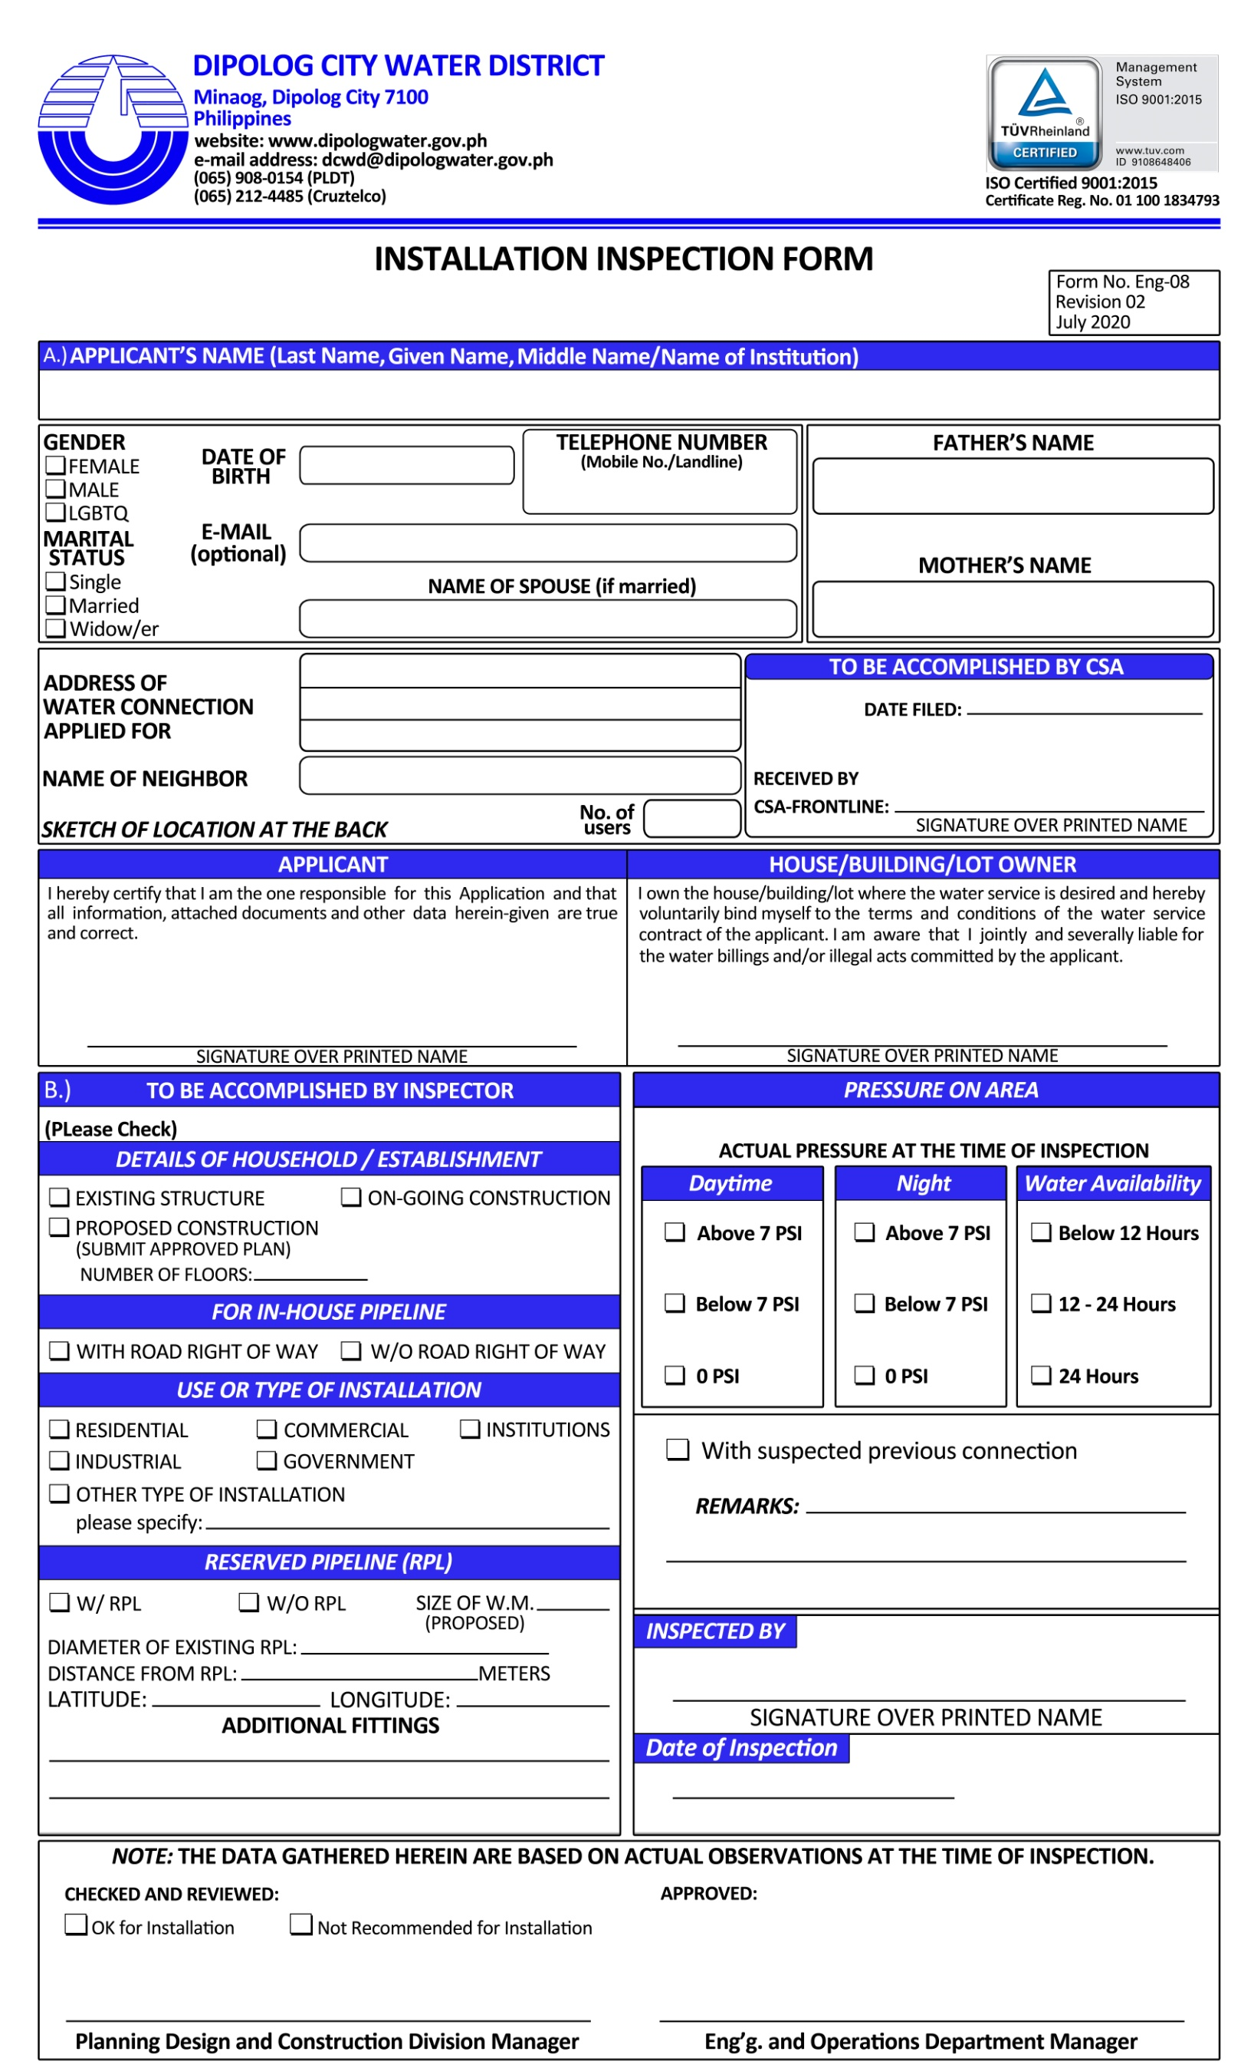

Form No.: Com-05
October 2020
Revision 01
DIPOLOG CITY WATER DISTRICT
Highway Minaog, Dipolog City

DATE: __________________

AUTHORIZATION LETTER

That I, _________________________________________________, of legal age, single/married and a resident of ____________________________________________, do hereby grant a permission to Mr./Mrs./Miss ___________________________________________, who is a ( ) tenant, ( ) boarder, ( ) occupant ( ) lessee, ( ) others (pls. specify_________________) of my building/ lot/ dwelling unit located at ________________________________________________ to transact and sign any pertinent documents in my behalf with the DIPOLOG CITY WATER DISTRICT for: ( Please Check √)

____a. Application for Water Service Connection
____b. Reconnection of Water Service Connection
____c. Voluntary Disconnection of Water Service Connection
____d. Transfer of Ownership and or Change Name
____e. Application for Senior Citizen‘s Discount
____f. Others (please specify) ___________________

____________________________________ ____________________________________
SIGNATURE OVER PRINTED NAME LOT OWNER’S SIGNATURE OVER PRINTED NAME
OF APPLICANT/ AUTHORIZED REPRESENTATIVE

LOT/ HOME OWNER’S UNDERTAKING

This is to attest the truth of the following matters and to impose upon myself the obligations attached thereon;
a. That the applicant is fully known to me to be the same person as herein above mentioned;
b. That I am solidarily liable to pay in case the aforesaid person cannot make good of his/ her accountabilities arising from nonpayment of water bills and other indebtedness to your office without prejudice of refund if the same be fully paid; and
c. That I am executing this document without compulsion and made by myself to abide with the policies stipulated in the CONTRACT FOR WATER SERVICE.

Given this ____day of _______________.

___________________________________
LOT OWNER’S SIGNATURE OVER PRINTED NAME

CO-OWNER’S NAME AND SIGNATURE:

_________________________________ _________________________________
_________________________________ _________________________________
_________________________________ _________________________________

