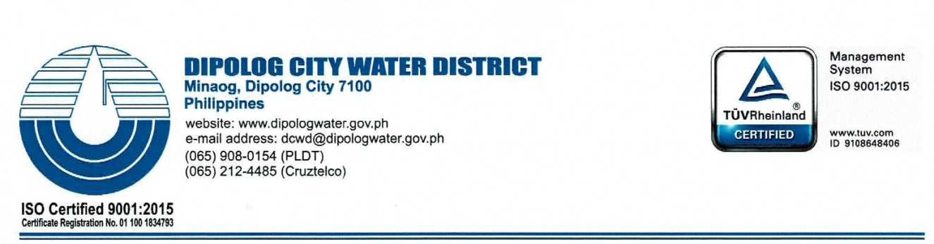
MEMORANDUM-ORDER

No. 18-42

TO: | Ms. Gracella B. Paluca; Ms. Cherry Lyn N. Dela Peña; Ms. Janet R. Nadala; Ms. Genelyn O. Empeynado
SUBJECT | DCWD SALN REVIEW & COMPLIANCE COMMITTEE
DATE | Sept 24,2018

Pursuant to CSC Resolution Nos. 1300455 & 150088 and in connection with the PBB requirements you are hereby directed to compose the DCWD SALN Review and Compliance Committee with the following structure hereunder:

Ms. Gracella B. Paluca- Chairperson
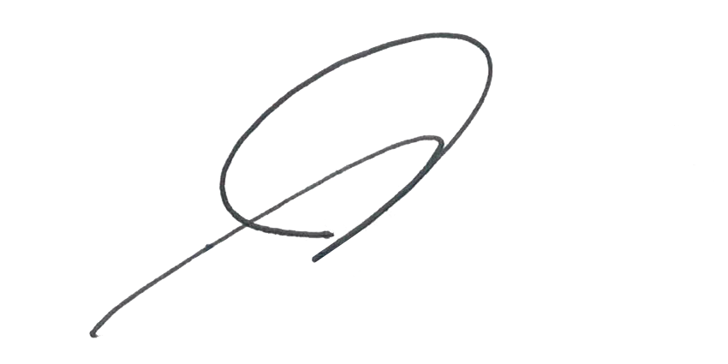
Ms. Cherry Lyn N. Dela Peña- Member
Ms. Janet R. Nadala- Member
Ms. Genelyn O. Empeynado- Member

For your compliance.

ANDREW R. MORALLO
General Manager

